EMPLOYEE EXPENSE TRACKING SYSTEM

USER MANUAL

TWIN-CIRCA MARKETING

ESPOSADO VILLAGE, CANNERY SITE

POLOMOLOK, SOUTH COTABATO 9504

**USER MANUAL VERSION: 1.0**

**MARCH 2021**

Table of Contents

Introduction 1

General Information 1

System Overview 1

Common Features 1

System Requirements 2

Hardware Requirements 2

Software Requirements 2

Getting Started 3

Starting the Web Application 3

Navigating the Web Application 3

Application Bar 3

Page Content 3

Navigation Drawer 4

Footer 5

Working with Data Tables 6

Filtering Data Table 6

Sorting Data Table 6

Refreshing Data Table 7

Showing Additional Row Data 7

Selecting Rows 7

Perform Actions on Rows 8

Pagination 8

Access, Authentication, and Authorization 9

Signing in to the Application 9

Roles and Permissions 9

Application Modules 13

Dashboard 13

Expense Summary 14

Expense Reports Summary 14

Expense by Category 14

Expense by Date 15

Filtering Records 15

Profile 16

Updating Information 16

Change Password 16

Expense 18

Creating New Expense 18

Editing Expense 20

Viewing Expense 21

Cancelling Expenses 22

Restoring Expenses 22

Filtering Records 23

Expense Report 24

Creating New Expense Report 24

Editing Expense Report 26

Viewing Expense Report 26

Submitting Expense Reports 27

Printing and Exporting Expense Reports 28

Approval and Rejection of Expense Reports 28

Cancelling Expense Reports 29

Duplicating Expense Reports 29

Filtering Records 30

Payment 31

Creating New Payment Record 31

Viewing Payment Record 33

Confirming Payment Records 34

Cancelling Payment Records 34

Filtering Records 35

Employee 36

Creating New Employee 36

Editing Employee 39

Viewing Employee 39

Resetting Employee Password 40

Editing Revolving Fund 41

Editing Permissions 42

Deactivating and Activating Employees 44

Deleting Employees 45

Restoring Employees 45

Filtering Records 46

Vendor 48

Creating New Vendor 48

Editing Vendor 49

Viewing Vendor 50

Deactivating and Activating Vendors 50

Deleting Vendors 51

Restoring Vendors 52

Filtering Records 53

Department 54

Creating New Department 54

Editing Department 55

Deleting Departments 55

Restoring Departments 56

Filtering Records 56

Job Designation 57

Creating New Job Designation 57

Editing Job Designation 58

Deleting Job Designations 58

Restoring Job Designations 58

Filtering Records 59

Expense Type 60

Creating New Expense Type 60

Editing Expense Type 61

Deleting Expense Types 61

Restoring Expense Types 62

Filtering Records 63

Activity Logs 64

Filtering Records 64

Notifications 65

Change Read Status 65

Filtering Records 65

Settings 66

Employee Settings 67

Appendices 68

Definition of Terms 68

Figures 69

Troubleshooting 71

Software Troubleshooting 71

Network Troubleshooting 71

Important Notes 71

# Introduction

## General Information

This user manual has been created to outline the setup and system functionalities. This includes the system requirements, proper setup and configuration, tutorials for application modules, and other system considerations and specifications. This document also provides an overview of the system to depict different aspects of the system and functions as a reference for system users.

## System Overview

The Employee Expense Tracking System is a web-based application that manages travel-related expenses of employees. It allows users to record, submit, track, process, and reimburse employee expenses. The system used to improve and streamline current process, data management and increase response time.

## Common Features

*Record Keeping*

The application is used in storing data to keep accurate records. Usual data that comprise overall transaction include employee information, vendors, expenses, and payment records.

*Status Monitoring*

The application is used for monitoring status of records mainly on expense reports submission and approval to avoid delays on employee reimbursement.

*Reporting*

The Employee Expense Tracking System provides an accurate data visualization for reporting and analysis. The system can generate summary of expense reports as well as overall expenses of the company.

## System Requirements

The minimum requirements for running the application required to operate the Employee Expense Tracking System are listed below:

### Hardware Requirements

* 1 x LCD/LED Monitor
* 1 x Computer Mouse
* 1 x Keyboard
* 1 x System Unit
  + 1 x VGA port
  + 2 x USB port
  + 1 x Ethernet port
  + RAM: 1 GB (32-bit) or 2 GB (64-bit systems); Recommended 4 GB or above
  + CPU: 1 GHz or higher
  + Hard disk space: 16 GB (32-bit) or 20 GB (64-bit systems); Recommended 64 GB or above
* 1 x Inkjet Printer (300*300 DPI)
* Ethernet connection (LAN) or a wireless adapter (Wi-Fi)

### Software Requirements

* Operating System (Recommended: Latest version)

Supported operating systems include:

* + Microsoft Windows 7 / 8 / 10
  + MAC OS X 10.4 or later
  + Linux v.20 or later
* Web Browser (Recommended: Latest version)

Supported web browsers include:

* + Google Chrome v.58 +
  + Mozilla Firefox v.54 +
  + Microsoft Edge v.14 +
  + Safari v.10 +

# Getting Started

## Starting the Web Application

To access the application, open a web browser in your computer and then type in the link *http://192.168.1.99:82/* in the browser’s address bar. In the application, the login page will be loaded first, enter the username and password and click the Login button. The username and password are verified and cached on the Web application server for the remainder of the session. After a successful login, you will be redirected to the dashboard of the application.

## Navigating the Web Application

### Application Bar

The application bar is the primary source of site navigation found on topmost section of every page. This consists of a navigation drawer menu, the home menu (labeled as the application’s name), notifications menu, and logout menu.



Figure 1 Application Bar

### Page Content

The page content refers to all the information contained in a website. Page content can be displayed as text, links, images, audio, animation or videos among other things.

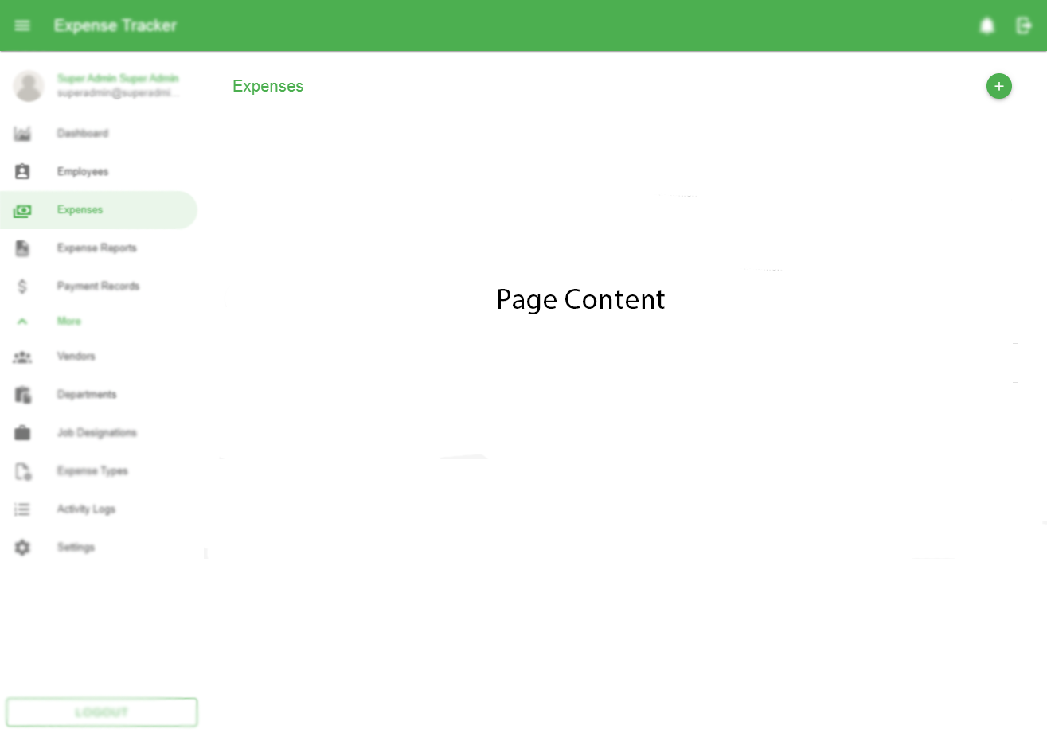

Figure 2 Page content

Common Page Content menus:

* + Page Title – This is used to specify the content of the webpage. Located at the top-left or top-right corner of the page.
  + Action Buttons – This is used to perform specific actions such as links which redirect the user to other pages.
  + Back button – This is a backward pointing arrow that returns the user to a previously shown window or web page.

### Navigation Drawer

The navigation drawer is what the users will utilize to navigate through the application. This is primarily used to house links to the pages and found on the leftmost section of the application.

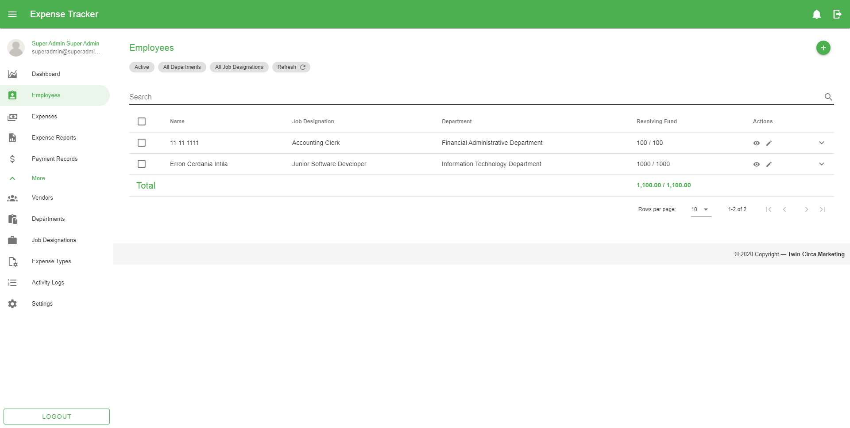

Figure 3 Navigation Drawer

### Footer

The footer is the section of content at the very bottom of the application that provides additional information. It contains a copyright notice and the company name.



Figure 4 Application footer

## Working with Data Tables

The data tables display a list of information consists of retrieved records from the database depending on the application’s modules.

### Filtering Data Table

The most basic functionality for filtering results is the search using the search bar found on top of every table list. This returns a list of matched records based on the typed characters in the text field.

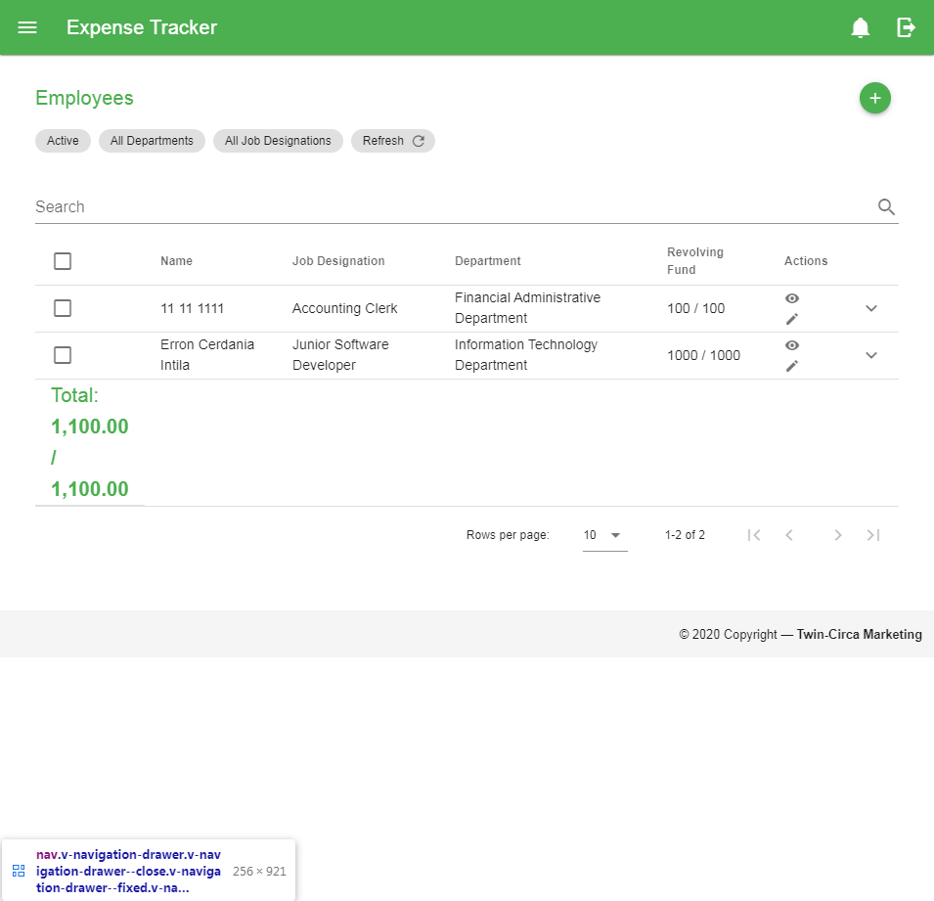

Figure 5 Search bar

Other filter options can be found on top of the search bar of every table list. Some filter options include status (mainly on expenses, reports, and payments including activation status of employees and vendors), selectors for employees, vendors, departments, and job designations. Refer to *Filtering Records* section for more details.

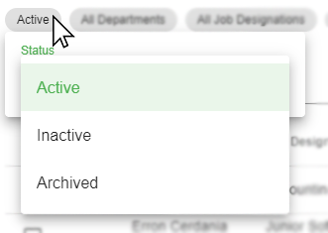

Figure 6 Status filter

### Sorting Data Table

Sorting table data can be done by clicking the column header in the table.

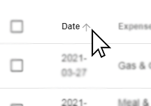

Figure 7 Sorting data table

### Refreshing Data Table

To refresh the records, click the refresh button found on top of the search bar.

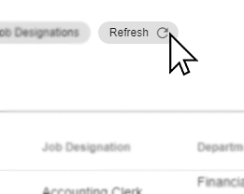

Figure 8 Refresh button

*Note: Clicking the refresh button will refresh/reset selected filters.*

### Showing Additional Row Data

By clicking the dropdown button found on the rightmost part of every row in the table provides more information of a certain row in the table.

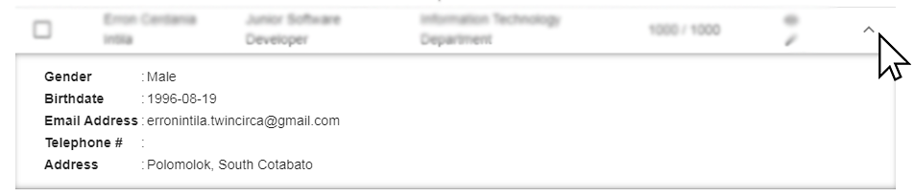

Figure 9 Showing additional row data

### Selecting Rows

To select a certain row, click the checkbox found on leftmost part of every row in the table. The table can handle multiple selection and perform specific actions at once. To select all records, click the first column header with the checkbox and vice-versa.

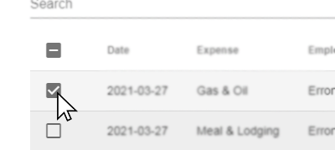

Figure 10 Selecting data table row data

### Perform Actions on Rows

Common action buttons such as show and edit buttons can be found on the right part of every row in the table within the ‘*Actions’* column

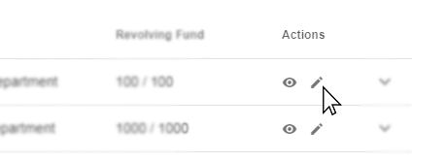

Figure 11 Perform actions on a row data

To perform special actions, additional buttons will be shown on top of the table/search bar after selecting record/s in the table.

### Pagination

Pagination provides a way of separating long sets of data so that it is easier for the user to consume information. This can be found at the bottom of the table. This also consists of a dropdown option for providing how many rows can be displayed on every page.



Figure 12 Pagination

## Filtering Records

Filter options are used to provide a range of data based on supplied criteria, and extracts matching records. These are the common filter options present in different application modules:

### Search Bar

The search bar is commonly used when filtering records particularly on Data Tables found on top of every table list. This returns a list of matched records based on the typed characters in the text field.



Figure 13 Search Bar

### Date Range Picker

Date range picker is used commonly on records that have date associated with it e.g. Expense, Expense Reports, or Payment records. These are the steps to use the filter:

1. Click the Date Range picker (usually found below the page content title) to open the dialog.

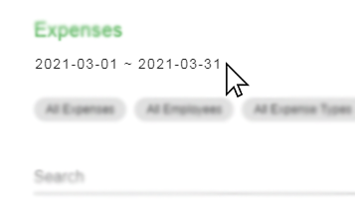

Figure 14 Date Range Picker Button

1. Select the starting and ending dates and click OK to filter.

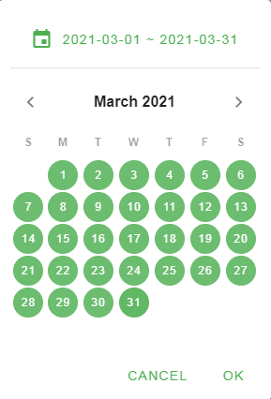

Figure 15 Date Range Picker

### Status Filter

The status filter is used to filter records based on their statuses i.e. Active, Inactive, and Archived. These are the steps to use the filter:

1. Click the ‘Status’ dropdown button usually located at the top of the search bar.

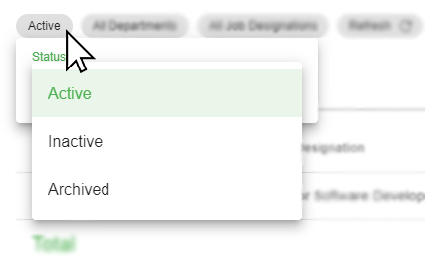

Figure 16 Status Filter

1. Select the status from the options list to filter.

There are other status filters specific only on the records of each application modules. These status filters include:

1. Expense Status Filter

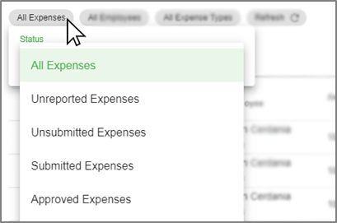

Figure 17 Expense Status Filter

1. Expense Report Status Filter

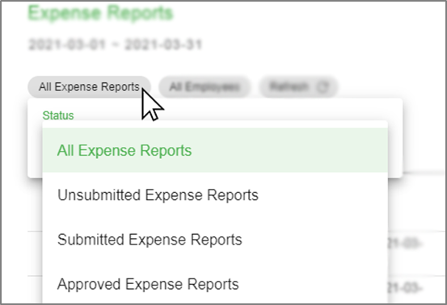

Figure 18 Expense Report Status Filter

1. Payment Status Filter



Figure 19 Payment Status Filter

1. Notification Status Filter

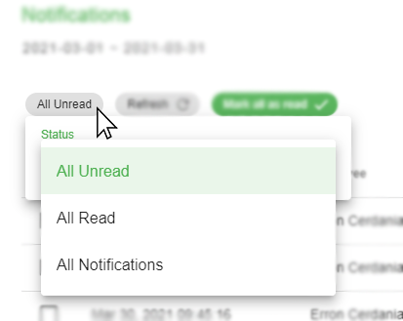

Figure 20 Notification Status Filter

### Employee Selector

This selector is used to filter records that are associated with employee records such as expenses and expense reports. These are the steps to use the filter:

1. Click the ‘Employee Selector’ button located at the top of the search bar to open the dialog.

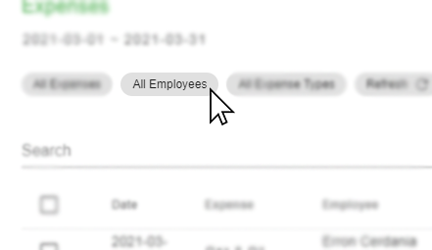

Figure 21 Employee Selector Button

1. Select the employee from the list.

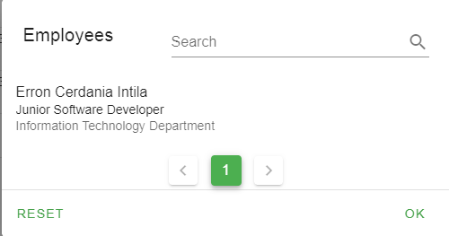

Figure 22 Employee Selector

### Department Selector

This filter provides the records that are associated with the selected department. Commonly used on selecting employee records. These are the steps to use the filter:

1. Click the ‘Department’ dropdown button usually located at the top of the search bar.

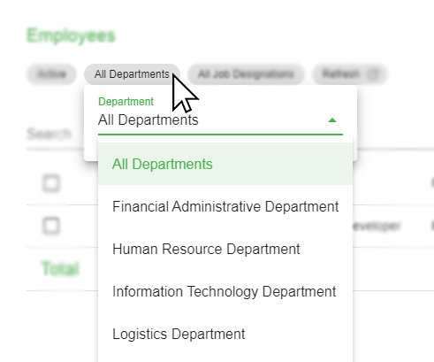

Figure 23 Department Selector

1. Select the department from the options list to filter.

### Job Designation Selector

This filter provides the records that are associated with the selected job designation. Commonly used on selecting employee records. These are the steps to use the filter:

1. Click the ‘Job Designation’ dropdown button usually located at the top of the search bar.

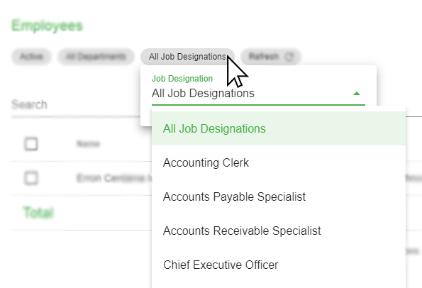

Figure 24 Job Designation Selector

1. Select the job designation based on selected department from the options list to filter.

## Access, Authentication, and Authorization

### Signing in to the Application

A user account allows you to sign in to the application. By default, the application already has one user account, the *Super Admin* account with the username ‘*superadmin’* and ‘*password’* as the default password. This account can’t be deleted and used mainly on setting up the entire application on first use, which includes creation of users for expense management and managing application settings.

To sign in, go to the login page of the application (http://192.168.1.99:82/login), type in the username and password and click the Login button. Then you will be redirected to the application’s dashboard after a successful login.

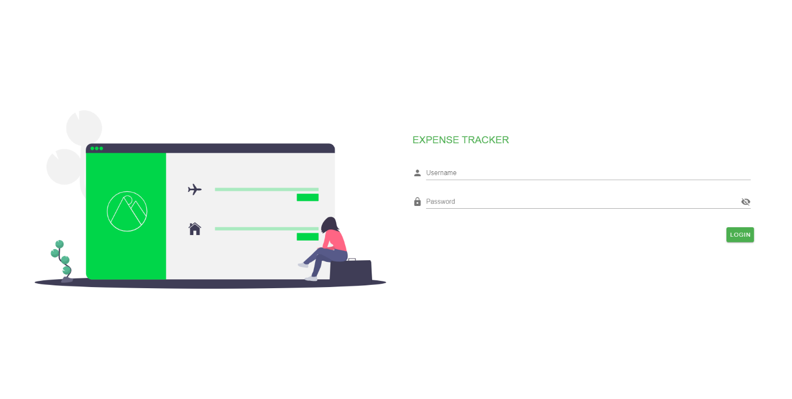

Figure 25 Login page

### Roles and Permissions

In setting up users for the application, each user can be classified into different roles and accompanied by permissions. The application has two main roles namely the Standard User and Administrator.

*Standard User*

This role provides basic access to the application. As a Standard user, you can do just about anything you would need to do, such as creating expense, submitting report, and managing user profile.

*Administrator*

This is a special role used for making changes to system settings, or managing user accounts or other application records. This role has full access to every setting on the application.

Each role has a set of permissions that can be enabled/disabled by the administrator. Here is the list of permissions that can be assigned on different roles:

|  |  |  |
| --- | --- | --- |
| Permission | Standard User | Administrator |
| add users |  | **✓** |
| edit users |  | **✓** |
| delete users |  | **✓** |
| view users |  | **✓** |
| view all users |  | **✓** |
| export users |  | **✓** |
| reset user passwords |  | **✓** |
| edit users fund |  | **✓** |
| restore users |  | **✓** |
| edit permissions |  | **✓** |
| set user activation |  | **✓** |
| add departments |  | **✓** |
| edit departments |  | **✓** |
| delete departments |  | **✓** |
| view departments |  | **✓** |
| view all departments |  | **✓** |
| export departments |  | **✓** |
| add jobs |  | **✓** |
| edit jobs |  | **✓** |
| delete jobs |  | **✓** |
| view jobs |  | **✓** |
| view all jobs |  | **✓** |
| export jobs |  | **✓** |
| add vendors |  | **✓** |
| edit vendors |  | **✓** |
| delete vendors |  | **✓** |
| view vendors |  | **✓** |
| view all vendors |  | **✓** |
| export vendors |  | **✓** |
| restore vendors |  | **✓** |
| set vendor activation |  | **✓** |
| add expense types |  | **✓** |
| edit expense types |  | **✓** |
| delete expense types |  | **✓** |
| view expense types |  | **✓** |
| view all expense types |  | **✓** |
| export expense types |  | **✓** |
| add payments |  | **✓** |
| edit payments |  | **✓** |
| delete payments |  | **✓** |
| view payments | **✓** | **✓** |
| view all payments | **✓** | **✓** |
| export payments |  | **✓** |
| receive payments | **✓** | **✓** |
| add expense reports | **✓** | **✓** |
| edit expense reports | **✓** | **✓** |
| delete expense reports | **✓** | **✓** |
| view expense reports | **✓** | **✓** |
| view all expense reports | **✓** | **✓** |
| export expense reports |  | **✓** |
| submit expense reports | **✓** | **✓** |
| submit expense reports beyond due date | **✓** | **✓** |
| approve expense reports |  | **✓** |
| approve expense reports beyond due date |  | **✓** |
| reject expense reports |  | **✓** |
| duplicate expense reports | **✓** | **✓** |
| add expenses | **✓** | **✓** |
| edit expenses | **✓** | **✓** |
| delete expenses | **✓** | **✓** |
| view expenses | **✓** | **✓** |
| view all expenses | **✓** | **✓** |
| export expenses |  | **✓** |
| add expenses beyond encoding period | **✓** | **✓** |
| add expenses beyond limit | **✓** | **✓** |
| set reimbursable amount | **✓** | **✓** |
| restore expenses | **✓** | **✓** |
| view all activity logs |  | **✓** |
| modify taxes on expense | **✓** | **✓** |
| manage settings |  | **✓** |

# Application Modules

## Dashboard

This module provides graphical representation for data visualization represented by charts and graphs. It consists views of key performance indicators and other information relevant to the company’s employee expense management.

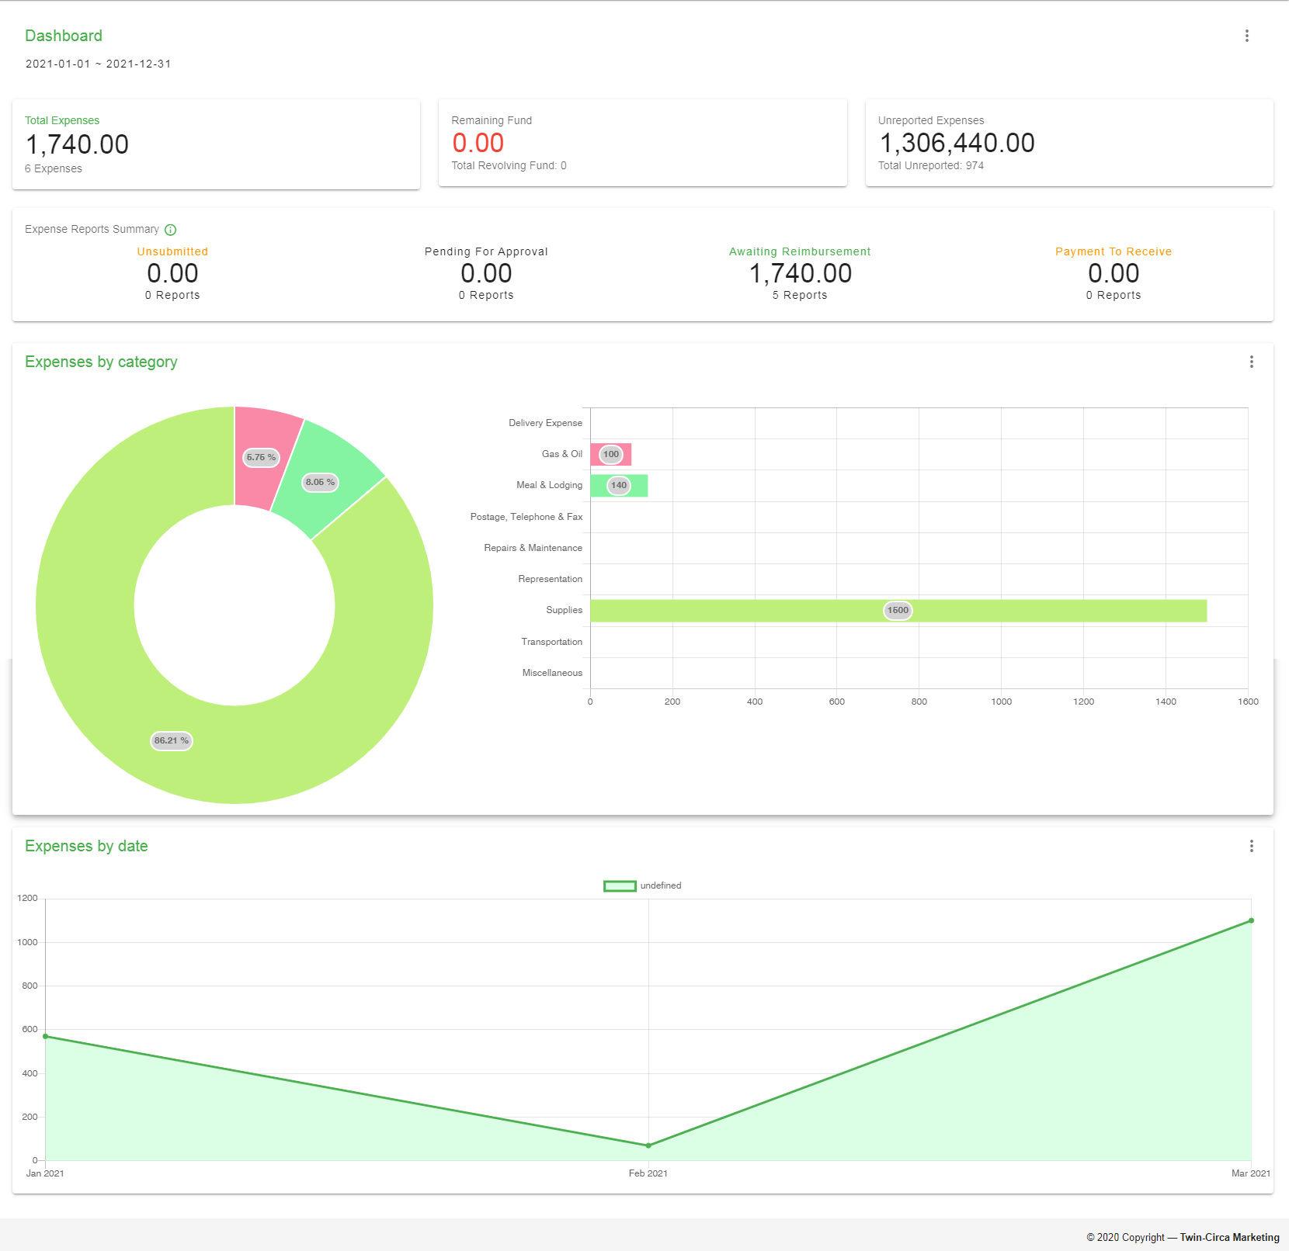

Figure 26 Dashboard

The Dashboard is divided into different sections that provides specific information and graphs to visualize the data represented. These sections are:

### Expense Summary

The expense summary provides information about the overall expenses spent by employees along with remaining fund to monitor and reimburse employees on time.



Figure 27 Expense Summary Dashboard Section

### Expense Reports Summary

The expense reports summary provides information on pending expense reports. This indicates the number and amount of expense reports on each status.



Figure 28 Expense Reports Summary Dashboard Section

This section is divided into four parts which corresponds to different status:

1. Unsubmitted – Created reports that are not yet submitted
2. Pending for Approval – Submitted reports waiting for approval
3. Awaiting Reimbursement – Approved reports waiting for payment
4. Payment to Receive – Reimbursed expenses waiting to be received by the user

### Expense by Category

This section shows a graphical representation of expenses based on categories such as expense types, employees, and departments.



Figure 29 Expense By Category Dashboard Section

### Expense by Date

This section shows a graphical representation of expenses based on date classified into different time units, i.e. day, week, month, quarter, and year.



Figure 30 Expense By date Dashboard Section

### Filtering Records

To filter records on different sections of the Dashboard, click the  icon located at the top-right of every section to show the list of filters that can be applied. All data represented by default is based on the current year except for the Expense Reports Summary section. To filter the overall Dashboard data by date, click the date picker located below the Page Content title, refer to the image shown below:

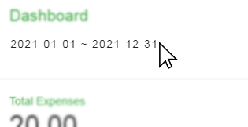

Figure 31 Dashboard Date filter

## Profile

This module is a record of personal, user-specific data associated with the user's identity. This also includes settings for updating personal and account information. This mainly contains the profile card located at the left part, and at the right part of the page, shows a form for updating information.

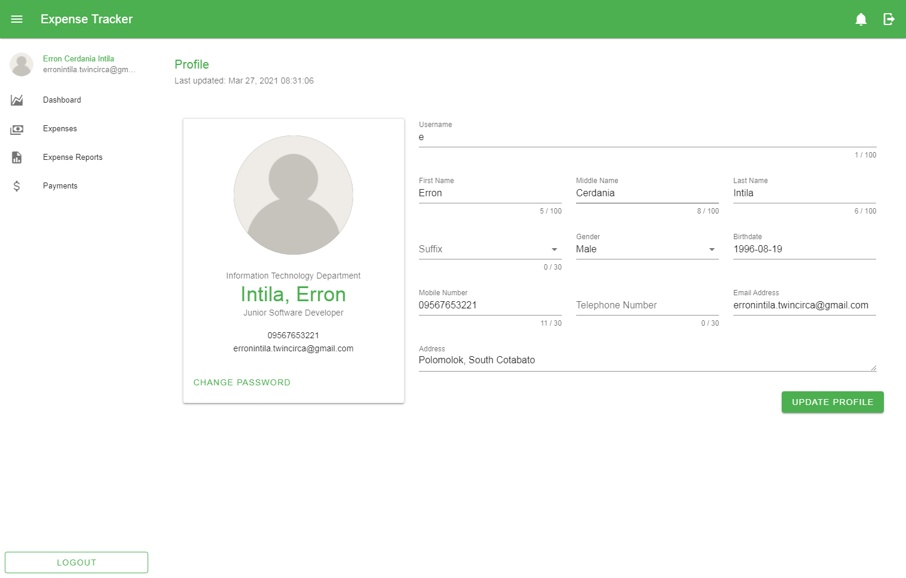

Figure 32 User Profile

### Updating Information

To update the information, fill in or change the information in the form fields and click the *‘Update Profile’* button at the bottom.

### Change Password

In changing the password, click the ‘*Change Password’* button located at the bottom part of the Profile Card to open the form and fill in the required details.

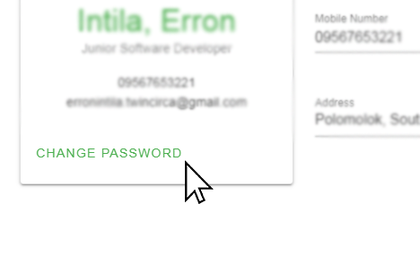

Figure 33 Change Password Button

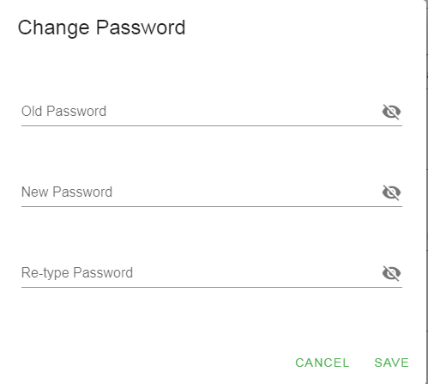

Figure 34 Change Password Form

The form contains the following:

1. Old Password – This is used to check if the user of the account is the actual user changing the password.
2. New Password – This field holds the information to update the old password.
3. Retype Password – This is used for password confirmation if the new password is typed in correctly.

*Note: If the user forgot the password, make a request to the administrator to reset the account password.*

## Expense

This module involves management of each employee expenses. This allows the user to view, add, edit, and cancel expenses depending on the user role and level of permissions given.

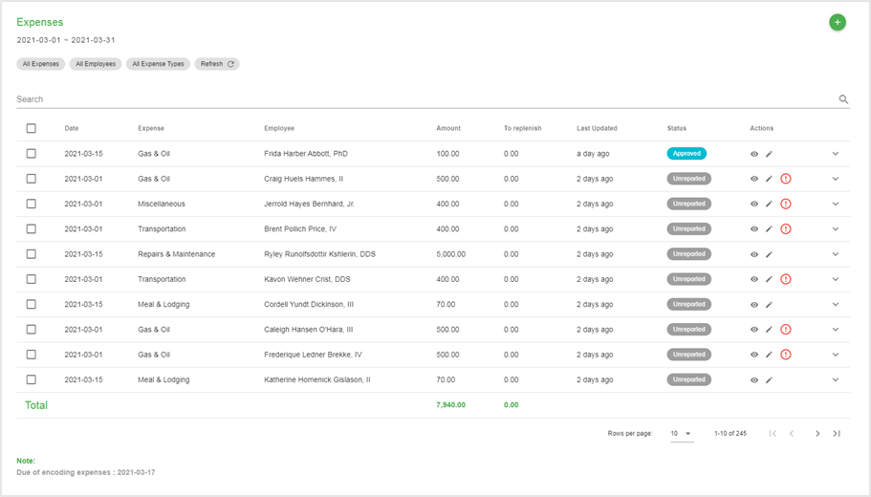

Figure 35 Expense Page

### Creating New Expense

These are the following steps in creating a new expense:

1. Go to the Expense page by navigating through the navigation drawer and click the Expenses menu.
2. In the Expense page, click the Add button located at the top-right corner of the page content.
3. Fill in the following details based on the image shown below.

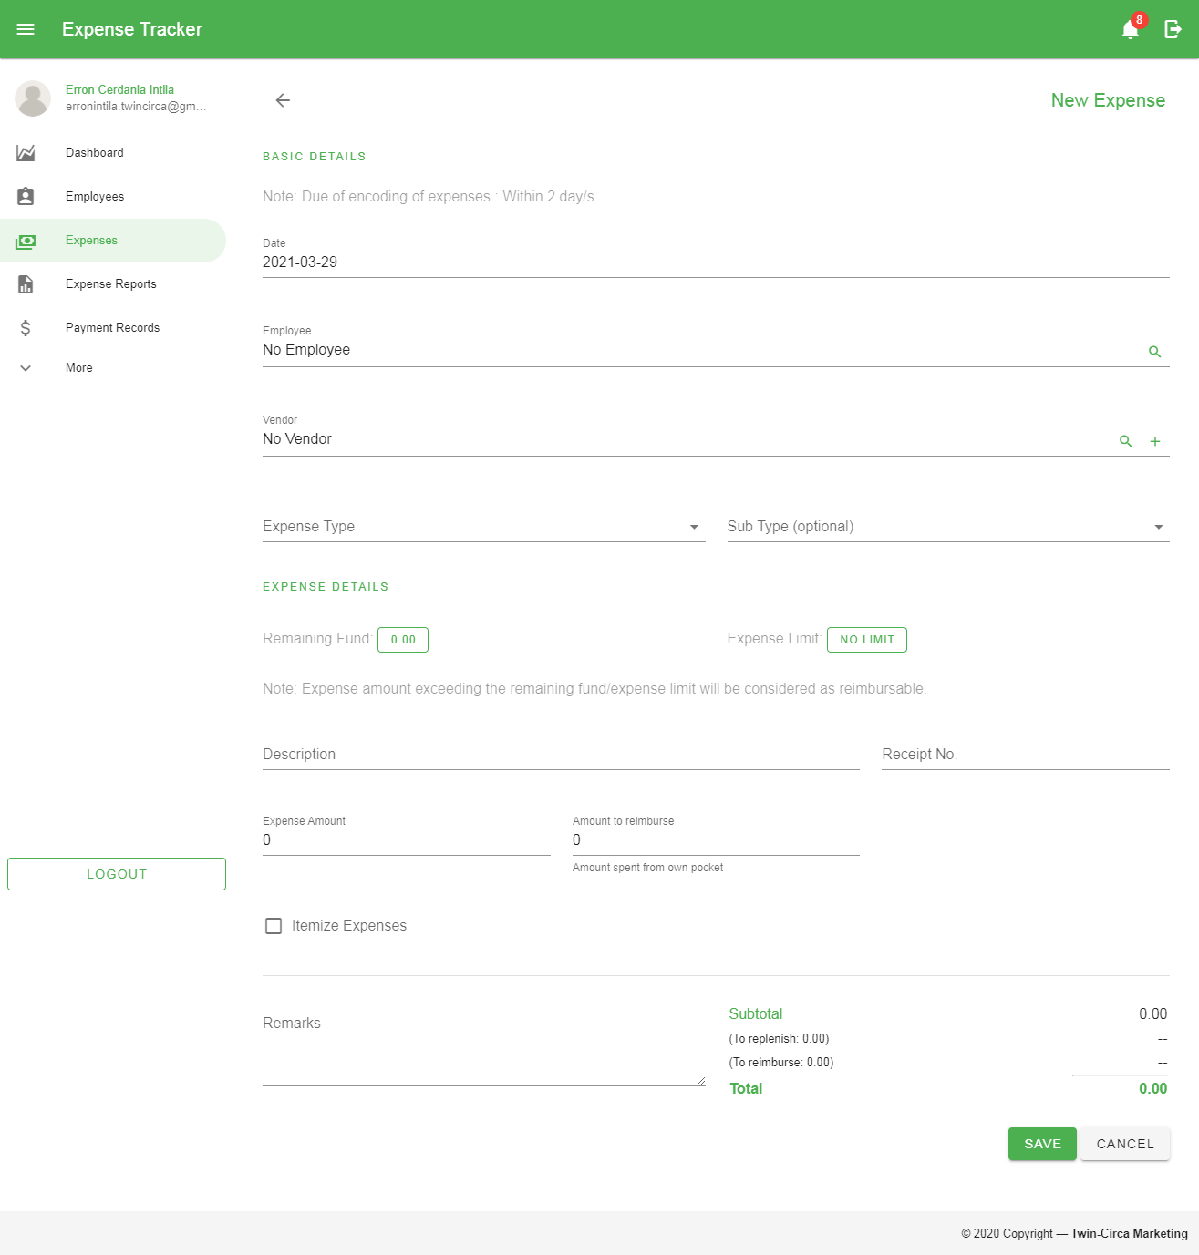

Figure 36 Create Expense Form

These are the following fields in the form:

* 1. *Date* – the date of the expense
  2. *Employee* – the employee who incurred the expenses
  3. *Vendor* – the person or business entity of which expenses have been incurred
  4. *Expense Type* – a classification of the expense
  5. *Sub Type* – a more detailed classification of the expense
  6. *Description* – used to describe what the expense is all about
  7. *Receipt No.* – a unique case number found in receipts
  8. *Expense Amount* – amount that an employee incurs
  9. *Amount to reimburse* – the amount of which the employee used to pay expenses on behalf of the company
  10. *Itemized Expenses* – a more detailed information of an expense

Check the *‘Itemize Expense’* checkbox to display the itemized expense table and action button for adding expenses.

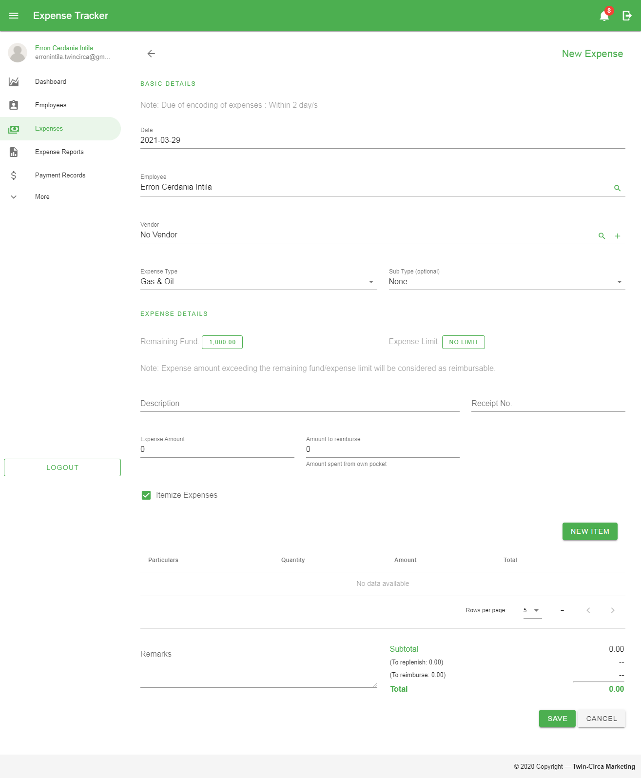

Figure 37 Itemized Expenses Table

When adding new record, click the *‘New Item’* button to open the form. Fill in the details needed to add new expense. Then click the ‘*Add’* button to add it on the table.

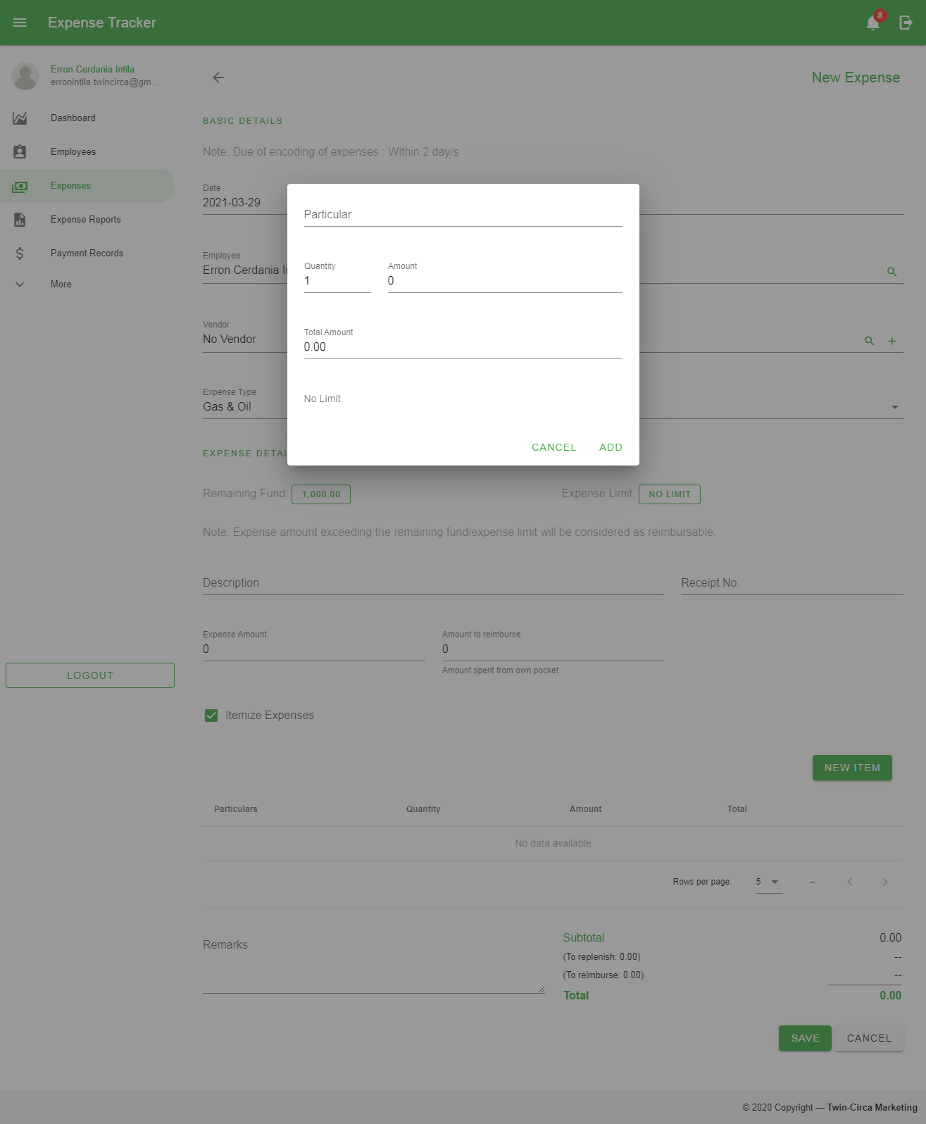

Figure 38 Add Expense Form for Itemized Expenses Record

* 1. *Remarks* – additional information of the expense record that needed to be taken into consideration

1. Click the *‘Save’* button located at the bottom of the page.

*Note: In creating expenses, the date of the expense must be in accordance with the allowed encoding period set by the administrator. In order to create expense records beyond the limit, make a request to the administrator for permission.*

### Editing Expense

These are the following steps in editing an expense:

1. In the Expense Page, click the Edit button 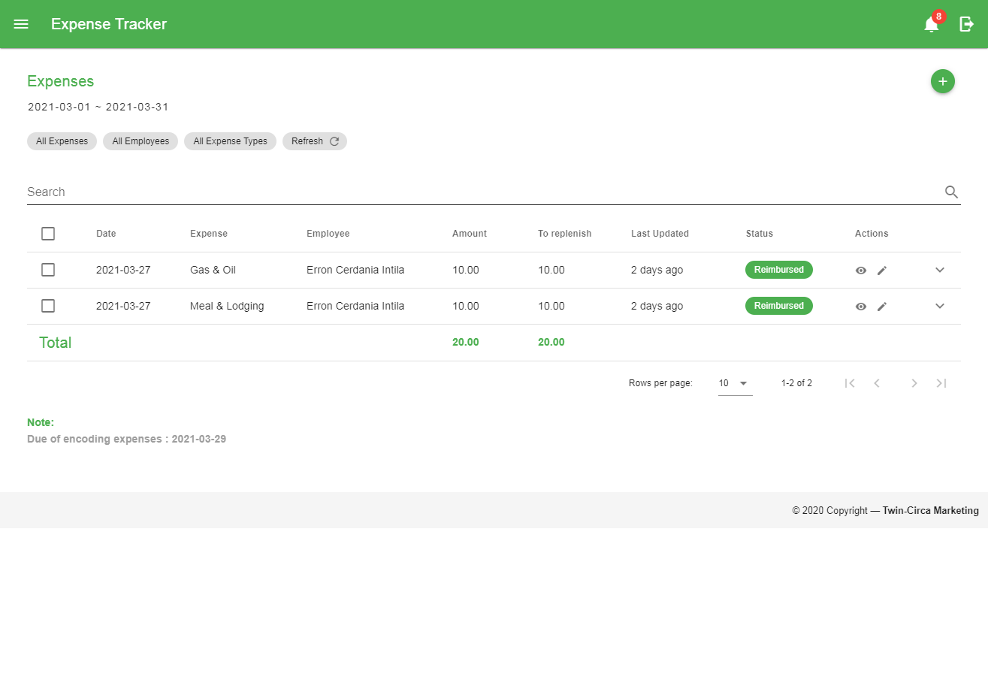 in a particular row in the data table located within the Action column to go to the Edit Page.
2. Fill in the details to be updated.
3. Click the Save button located at the bottom of the page.

*Note: Expenses can only be edited if the record has not been associated with any expense report. All expenses with an unapproved report can also be edited.*

### Viewing Expense

To view a specific record, click the Show button 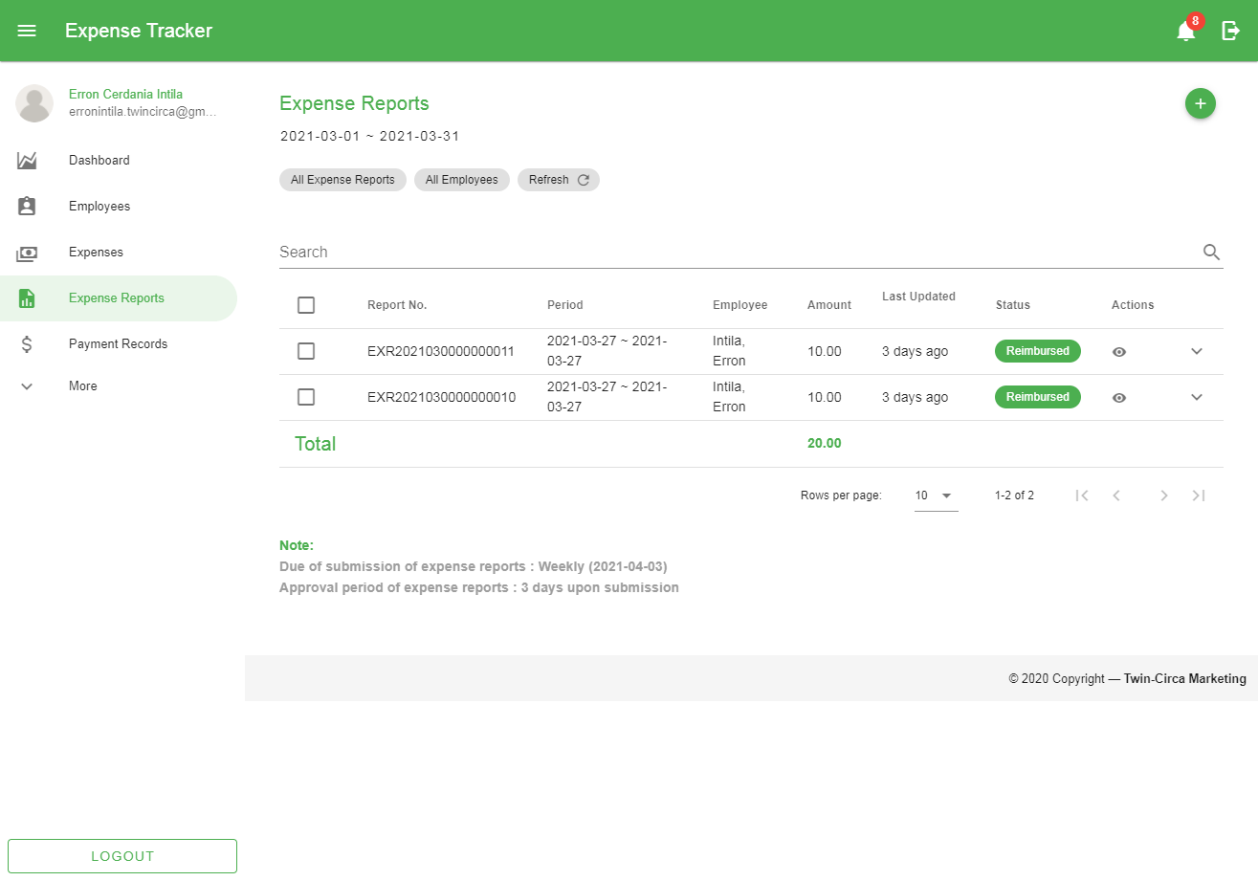 in a particular row in the data table located within the Action column to go to the View Expense page for a more detailed information.

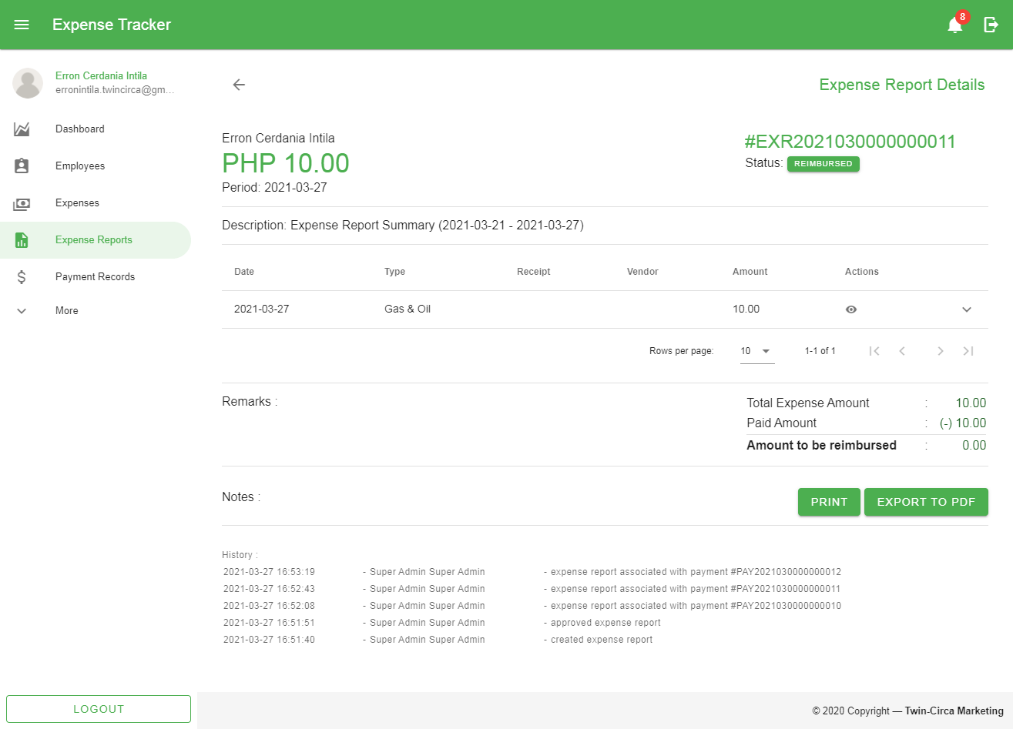

Figure 39 View Expense Page

### Cancelling Expenses

These are the following steps in cancelling an expense:

1. Select the expense record by checking the checkbox in the first column of the data table.
2. Click the *‘Cancel Expenses’* button shown above the Search bar along with other filter options.

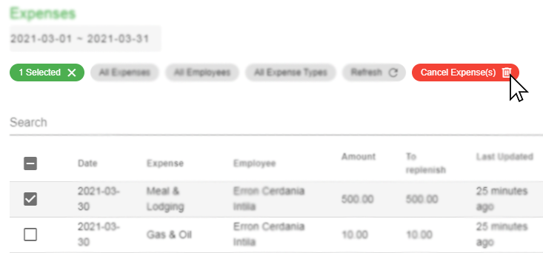

Figure 40 Cancelling Expenses

1. Click the *‘Yes’* button in the popup dialog to confirm the action.

### Restoring Expenses

These are the following steps in restoring an expense:

1. Filter the records through the Status filter located at the top of the search bar and select *‘Cancelled Expenses’*.
2. Select the expense record by checking the checkbox in the first column of the data table.
3. Click the ‘Restore Expenses’ button shown above the Search bar along with other filter options.

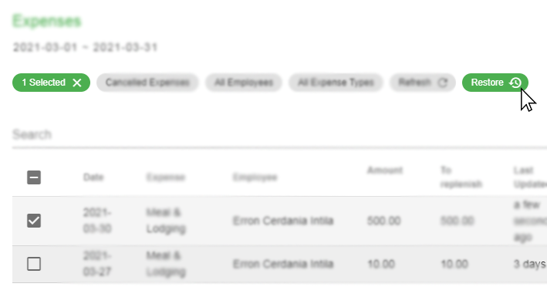

Figure 41 Restoring Expenses

1. Click the *‘Yes’* button in the popup dialog to confirm the action.

*Note: Cancelling and restoring expenses can only be done if the existing record has not been associated with any expense report.*

## Expense Report

This module allows the user to manage created expenses grouped into reports. This involves creation, submission, approval, rejection and cancellation of records. Each record has specific status used mainly for monitoring with regards to employee reimbursement.

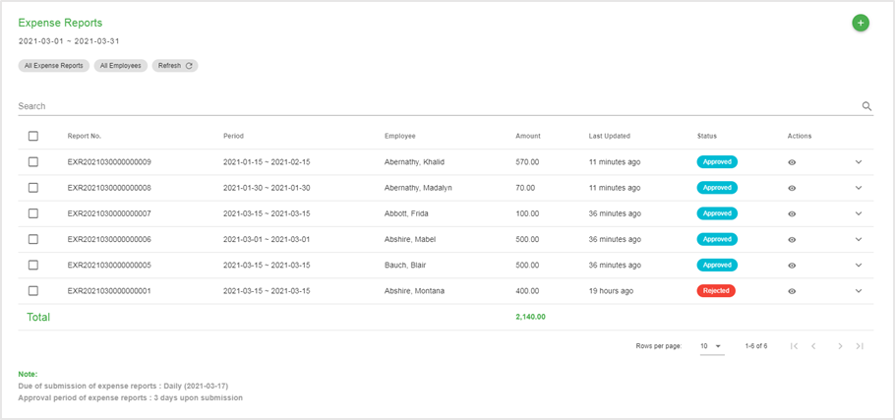

Figure 42 Expense Report page

### Creating New Expense Report

These are the steps in creating new report:

1. Go to the Expense Report page by navigating through the navigation drawer. Then click the Expense Report menu.
2. In the Expense Report page, click the ‘*Add’* button located at the top-right corner of the page content.
3. Fill in the following details based on the image shown below.

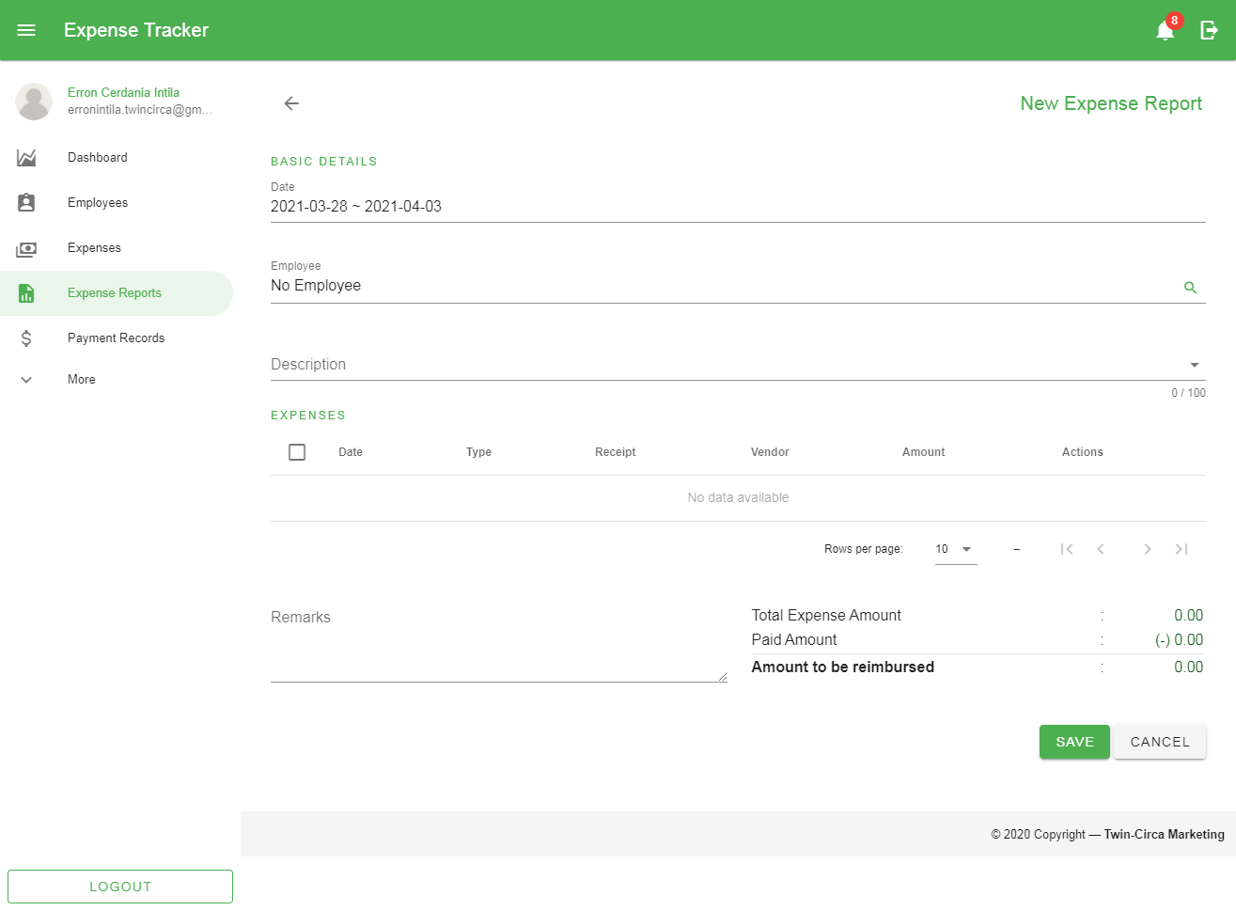

Figure 43 Expense Report Add Form

These are the following fields in the form:

* 1. *Date* – this is a date range picker used to filter the expenses needed to be retrieved and use within the report
  2. *Employee* – the employee responsible for the expense report
  3. *Description* – describes the content of the report
  4. *Expenses List* – the list of expenses retrieved based on the selection using the date range picker

To add expenses that will be included in the report, select from the list of records by clicking the checkboxes in the first column of the data table.

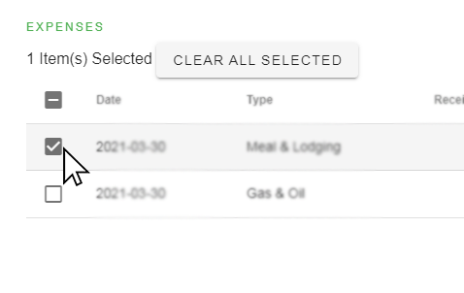

Figure 44 Selecting expenses for Expense Report

* 1. *Remarks* – additional information of the record that needed to be taken into consideration

1. Click the *‘Save’* button located at the bottom of the page.

### Editing Expense Report

These are the steps in editing an expense report:

1. In the Expense Report Page, click the Edit button  in a particular row in the data table located within the Action column to go to the Edit Page.
2. Fill in the details to be updated.
3. Click the Save button located at the bottom of the page.

*Note: Expense Reports can only be edited if the record has not been approved. Expense Reports with an approved status without any association with a payment record can only be edited by the administrator.*

### Viewing Expense Report

To view a specific record, click the Show button  in a particular row in the data table located within the Action column to go to the View Expense Report page for a more detailed information.

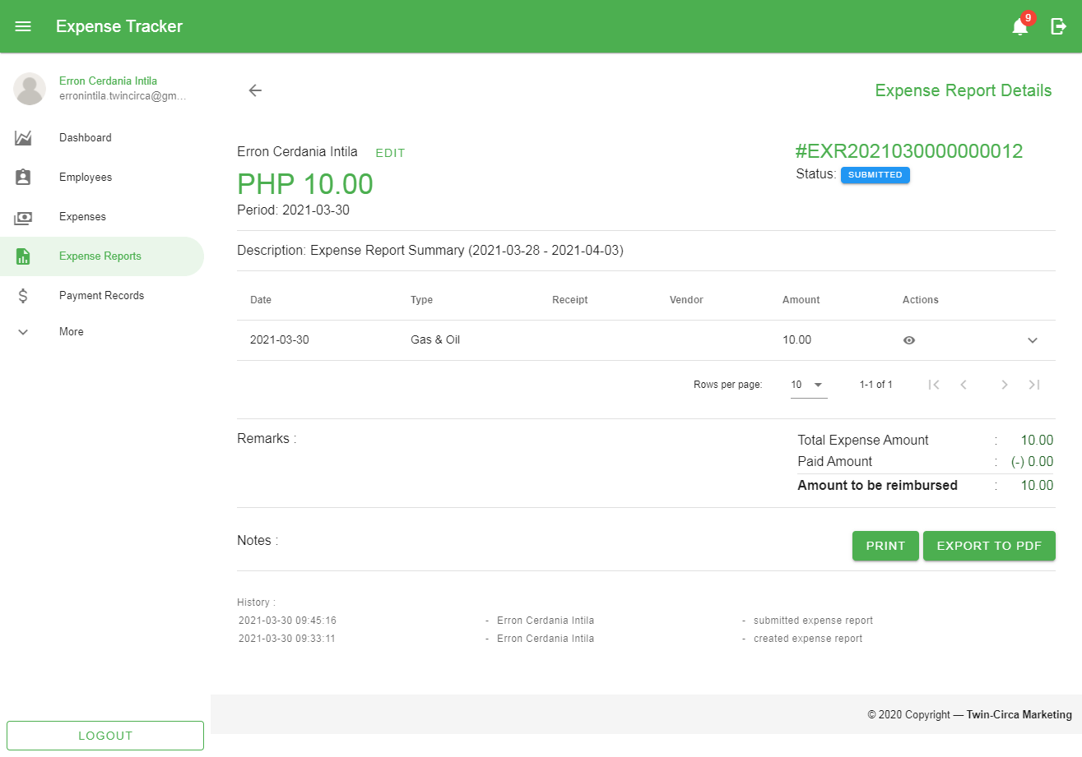

Figure 45 View Expense Report Page

### Submitting Expense Reports

These are the steps in submitting an expense report:

1. Select the record/s by checking the checkbox in the first column of the data table.
2. Click the ‘Submit’ button shown above the Search bar along with other filter options.

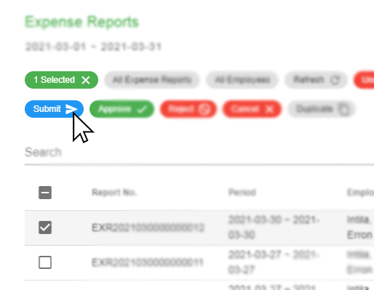

Figure 46 Submitting Expense Reports

1. Click the ‘Yes’ button in the popup dialog to confirm the action.

*Note: In submitting expense reports, the starting date of the expenses belong to the report must be in accordance with the allowed submission period set by the administrator. In order to submit records beyond the limit, make a request to the administrator for permission.*

### Printing and Exporting Expense Reports

In order to print the expense report, the record must be submitted first. The following steps include:

1. Select the record by checking the checkbox in the first column of the data table.
2. Click the ‘Print’ or ‘Export’ dropdown button shown below the data table.

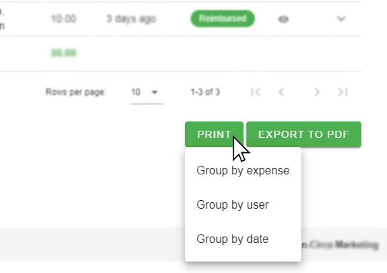

Figure 47 Printing/Exporting Expense Reports

The printing/exporting the selected record/s have three format:

* 1. Group by expense – The expenses of selected report/s are grouped by expenses along with their expense types.
  2. Group by user – The expenses of selected report/s are grouped by system users/employees.
  3. Group by date – The expenses of selected report/s are grouped based on expenses’ dates.

### Approval and Rejection of Expense Reports

These are the steps in approving or rejecting an expense report:

1. Select the record/s by checking the checkbox in the first column of the data table.
2. Click the ‘Approve’ or ‘Reject’ button shown above the Search bar along with other filter options.

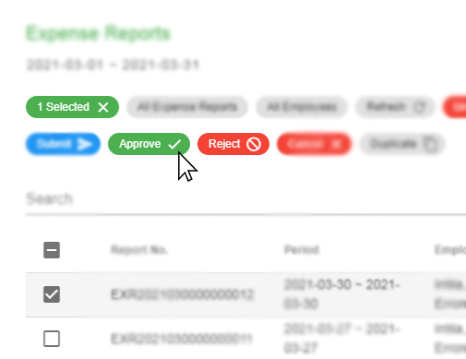

Figure 48 Approving/Rejecting Expense Reports

*Note: When rejecting expense reports, the user must provide an appropriate reason before confirming the action.*

1. Click the ‘Yes’ button in the popup dialog to confirm the action.

### Cancelling Expense Reports

These are the steps in cancelling expense report/s:

1. Select the record/s by checking the checkbox in the first column of the data table.
2. Click the ‘Cancel’ button shown above the Search bar along with other filter options.

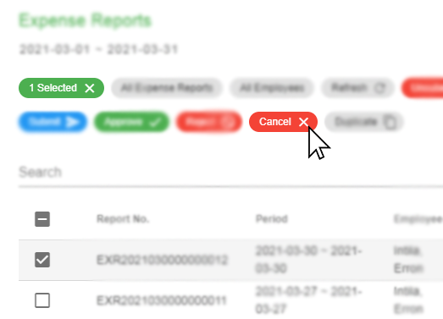

Figure 49 Cancelling Expense Reports

1. Click the ‘Yes’ button in the popup dialog to confirm the action.

### Duplicating Expense Reports

These are the steps in duplicating an expense report:

1. Select the record/s by checking the checkbox in the first column of the data table.
2. Click the ‘Duplicate’ button shown above the Search bar along with other filter options.

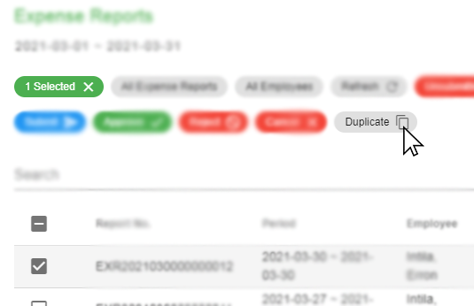

Figure 50 Duplicating Expense Reports

1. Click the ‘Yes’ button in the popup dialog to confirm the action.

*Note: Duplicating expense reports will go back to unsubmitted status. Expenses from the referenced expense report are also duplicated.*

## Payment

This module provides record of payments for approved expense reports. This also shows status of transaction whether a certain payment has been created or received by the employee.

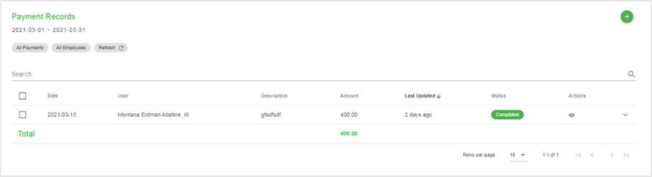

### Creating New Payment Record

These are the following steps when creating new payment:

1. Go to the Payment page by navigating through the navigation drawer. Then click the Payments menu.
2. In the Payment page, click the ‘Add’ button located at the top-right corner of the page content.
3. Fill in the following details based on the image shown below.

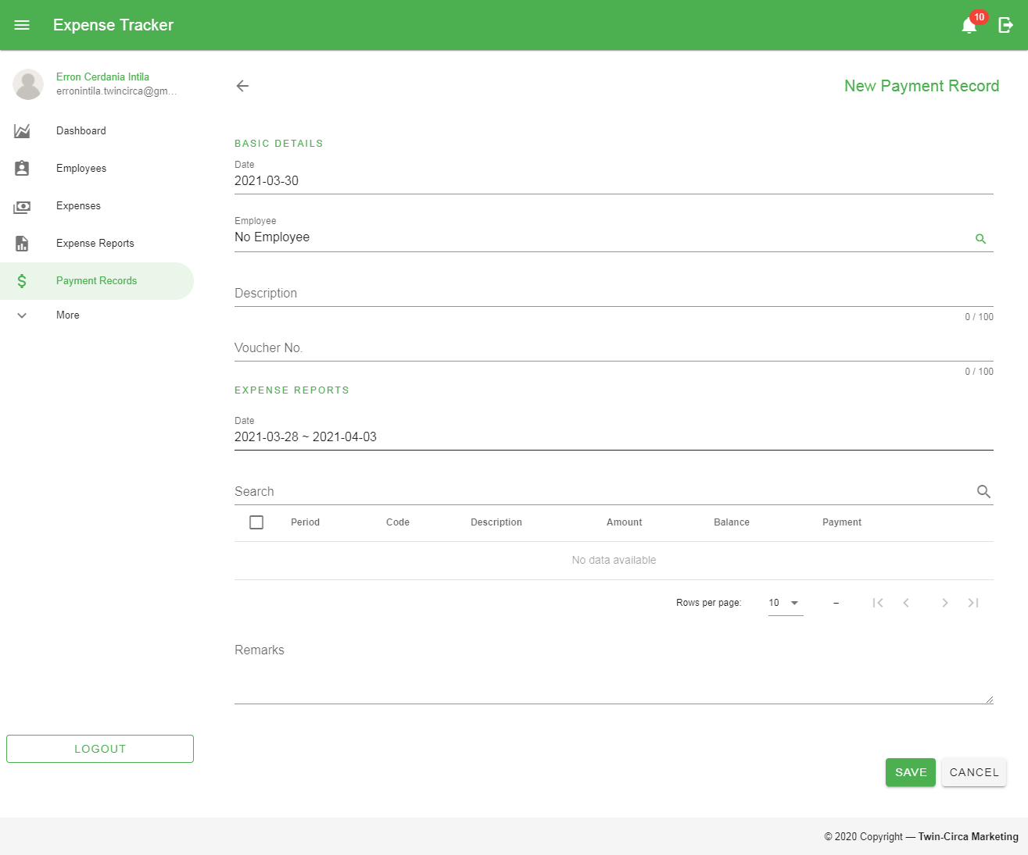

Figure 51 Payment Add Form

These are the following fields in the form:

1. Date – the date of the payment
2. Employee – the employee associated with the expense reports
3. Description – describes the content of the payment record
4. Voucher No. – a unique document number found in a payment voucher
5. Expense Reports – the list of expense reports retrieved based on the selection using the date range picker

To add expense reports that will be included in the payment, filter the results using the date range picker then select from the list of retrieved records by clicking the checkboxes in the first column of the data table.

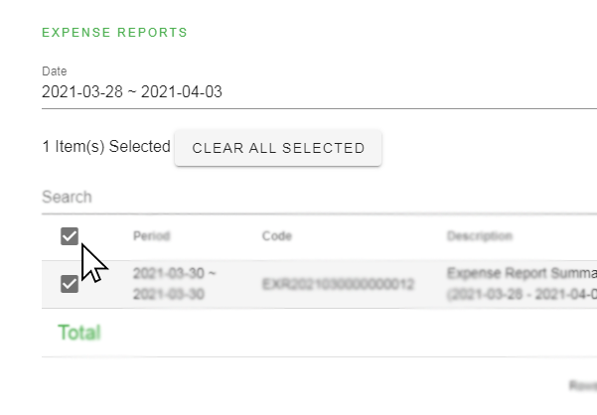

Figure 52 Selecting Expense Reports for Payment Record

1. Remarks – additional information of the record that needed to be taken into consideration
2. Click the *‘Save’* button located at the bottom of the page.

### Viewing Payment Record

To view a specific record, click the Show button  in a particular row in the data table located within the Action column to go to the View Payment page for a more detailed information.

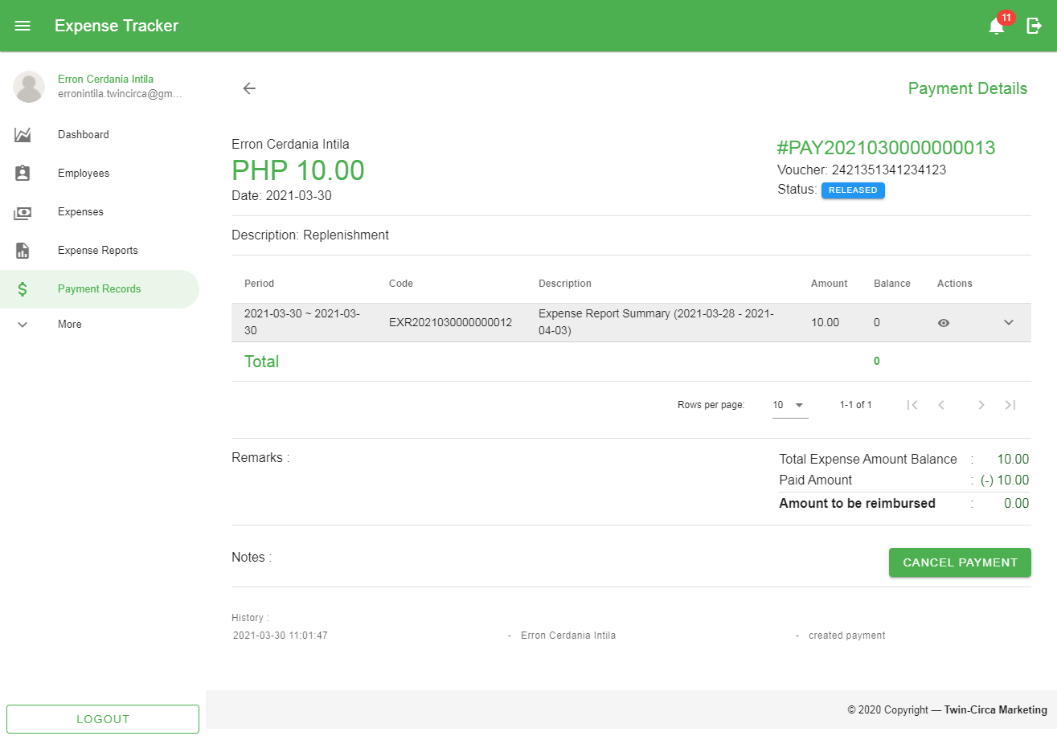

Figure 53 View Payment Page

### Confirming Payment Records

After creating payment record for expense report/s, confirming payment is required to complete the reimbursement process. The confirmation means that the payment has been received and is done by the employee associated with the reimbursed expenses. The following steps are:

1. Select the record/s by checking the checkbox in the first column of the data table.
2. Click the ‘Mark as Received’ button shown above the Search bar along with other filter options.

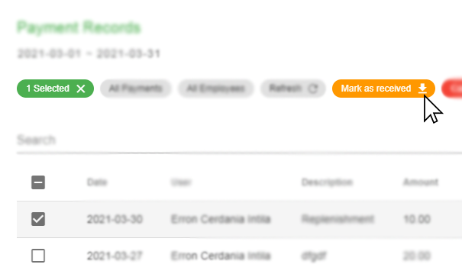

Figure 54 Marking Payment as Received

1. Click the ‘Yes’ button in the popup dialog to confirm the action.

### Cancelling Payment Records

Cancelling a payment record is considered a deleted information and cannot be restored. To cancel payment record/s:

1. Select the record/s by checking the checkbox in the first column of the data table.
2. Click the ‘Cancel Payment(s)’ button shown above the Search bar along with other filter options.

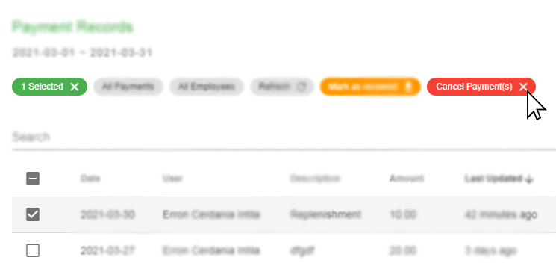

Figure 55 Cancelling Payment Record/s

1. Click the ‘Yes’ button in the popup dialog to confirm the action.

## Employee

This module allows the user to manage employee records. Each employee record is considered a system user accompanied with specific roles and permissions.

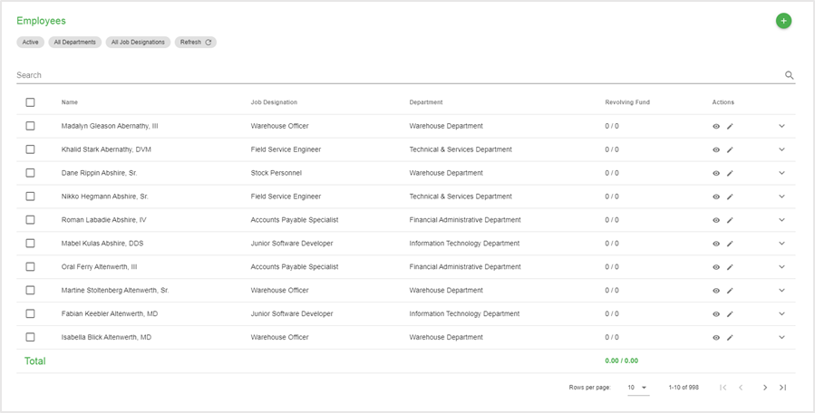

Figure 56 Employee Page

### Creating New Employee

These are the following steps in creating a new employee:

1. Go to the Employee page by navigating through the navigation drawer and click the Employees menu.
2. In the Employee page, click the Add button located at the top-right corner of the page content.
3. Fill in the following details based on the images shown below.

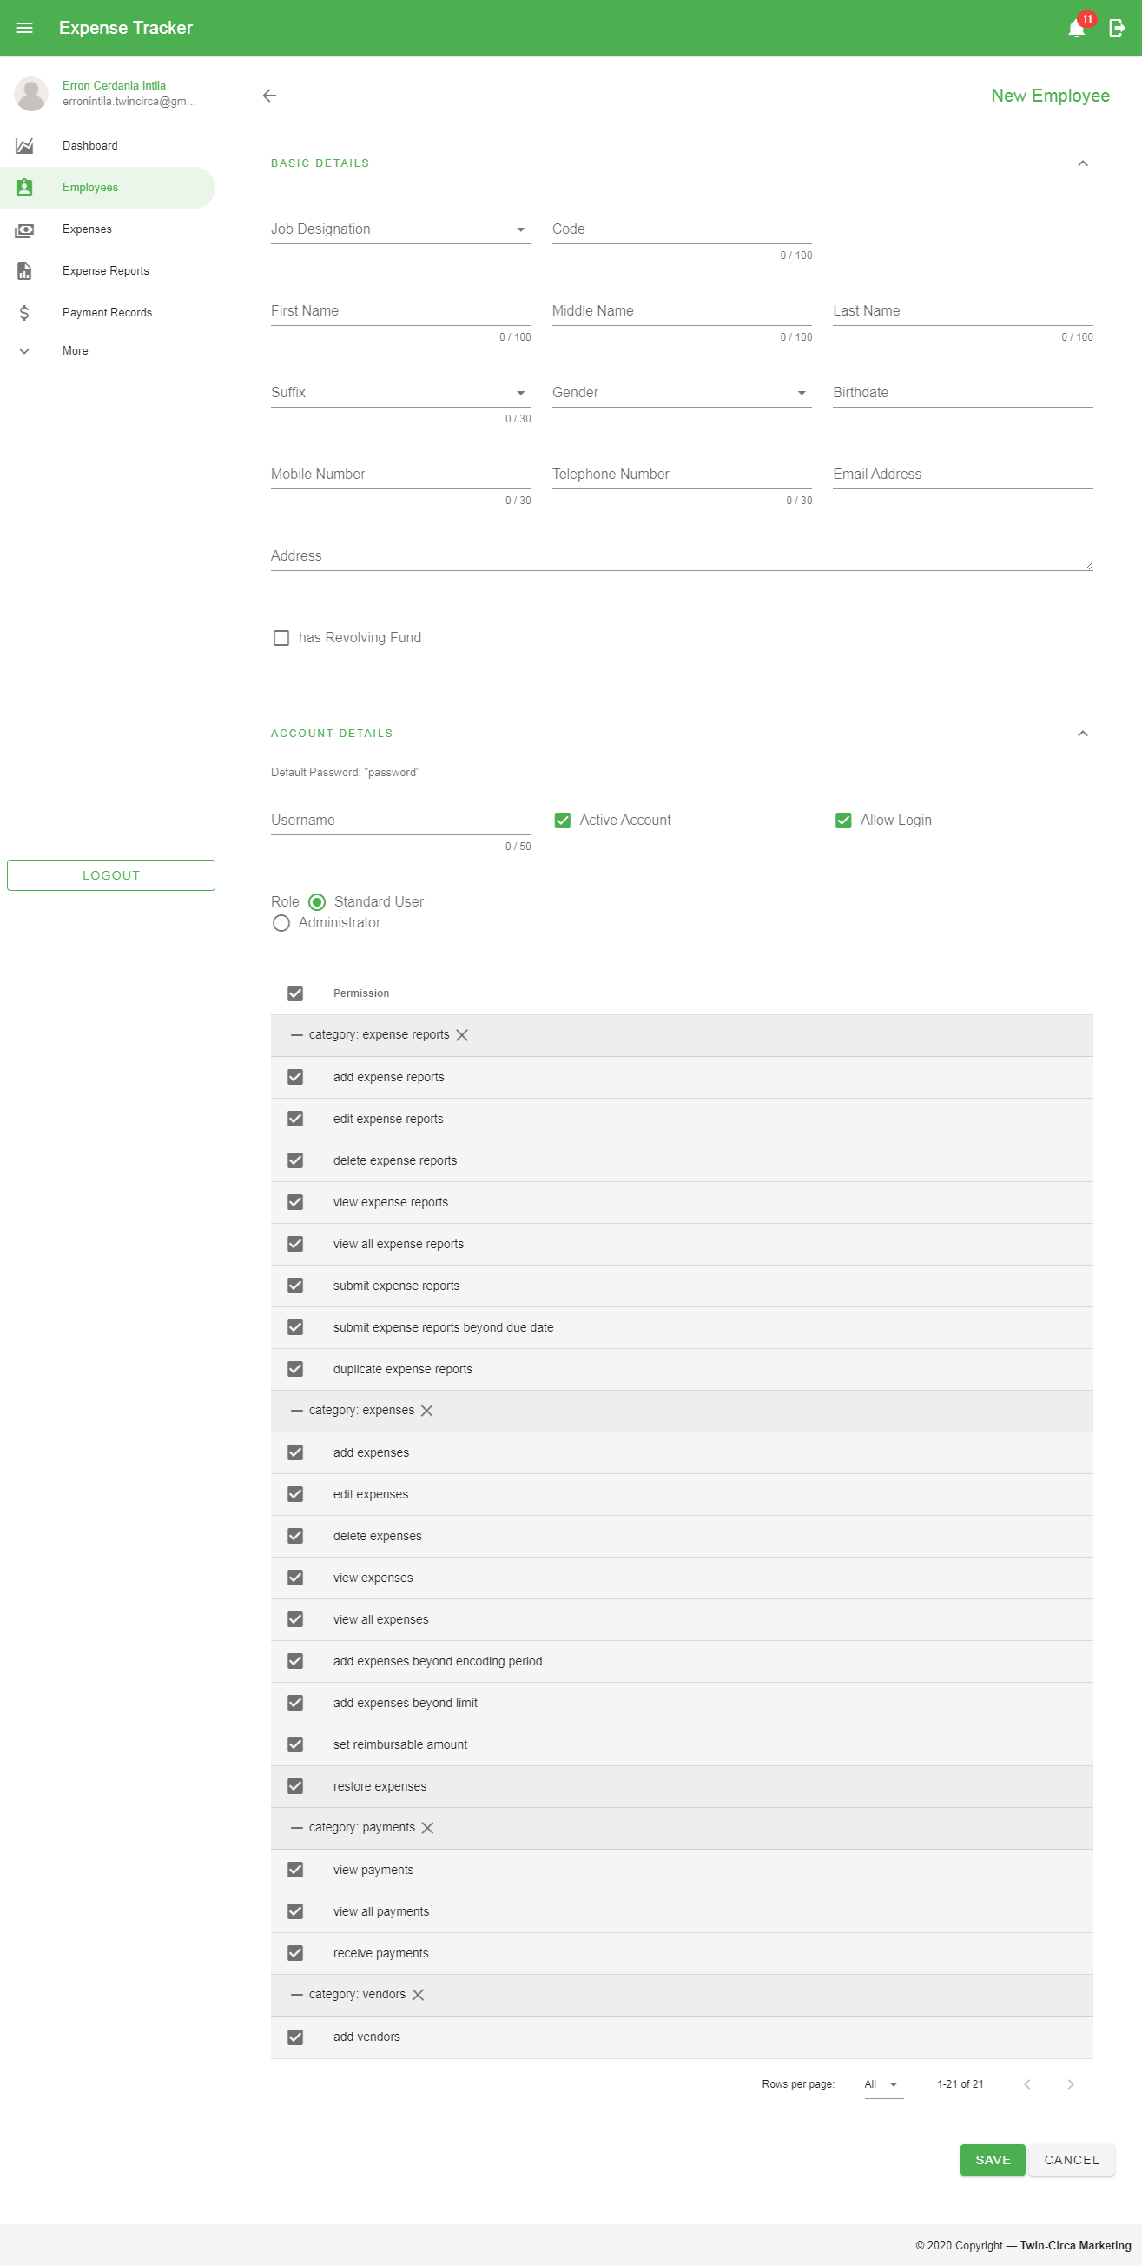

Figure 57 Employee Add Form (Basic Details)



Figure 58 Employee Add Form (Account Details)

These are the following fields in the form:

1. Job Designation
2. Code – a unique identifier for employees
3. First Name
4. Middle Name
5. Last Name
6. Suffix
7. Gender
8. Birthdate
9. Mobile Number
10. Telephone Number
11. Email Address
12. Address
13. Revolving Fund – amount
14. Username -
15. Active Account – used to specify users’ active status
16. Allow Login – used to provide login access to the users
17. Role – used to provide the users access to
18. Permissions – authorization provided to a specific user
19. Click the ‘Save’ button located at the bottom of the page.

### Editing Employee

These are the following steps in editing an employee:

1. In the Employee Page, click the Edit button  in a particular row in the data table located within the Action column to go to the Edit Page.
2. Fill in the details to be updated.
3. Click the ‘*Save’* button located at the bottom of the page.

### Viewing Employee

To view a specific record, click the Show button  in a particular row in the data table located within the Action column to go to the View Payment page for a more detailed information.

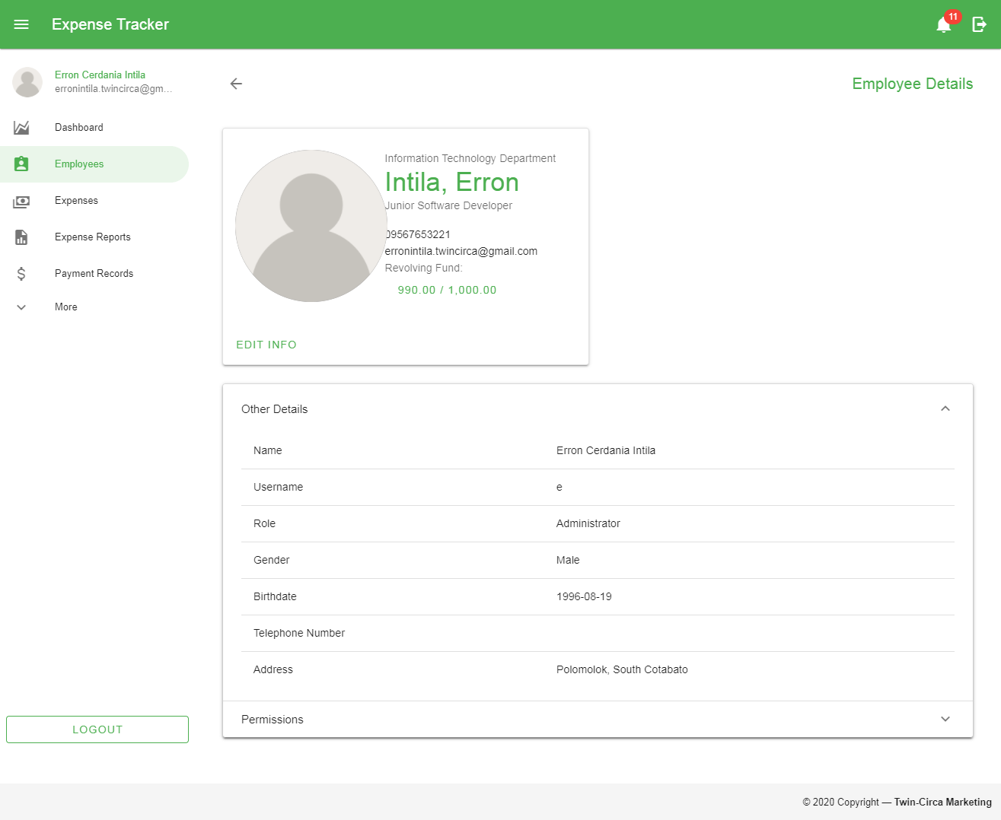

Figure 59 View Employee Page

### Resetting Employee Password

These are the steps in resetting employee password:

1. Select the record/s by checking the checkbox in the first column of the data table.
2. Click the ‘Reset Password’ button shown above the Search bar along with other filter options.

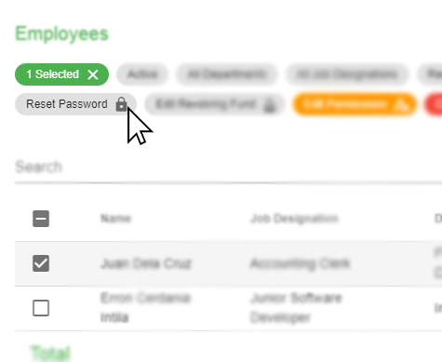

Figure 60 Employee Reset Password

1. Click the *‘Yes’* button in the popup dialog to confirm the action.

### Editing Revolving Fund

These are the steps in editing revolving fund:

1. Select the record by checking the checkbox in the first column of the data table.
2. Click the ‘Edit Revolving Fund’ button shown above the Search bar along with other filter options to go to the Edit Revolving Fund page.

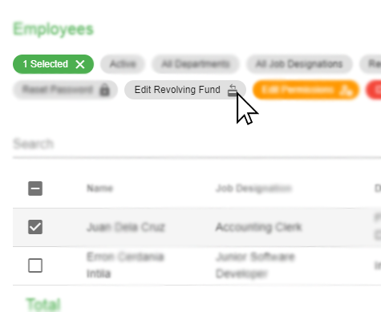

Figure 61 Edit Employee Revolving Fund

1. Fill in the following details based on the image shown below.

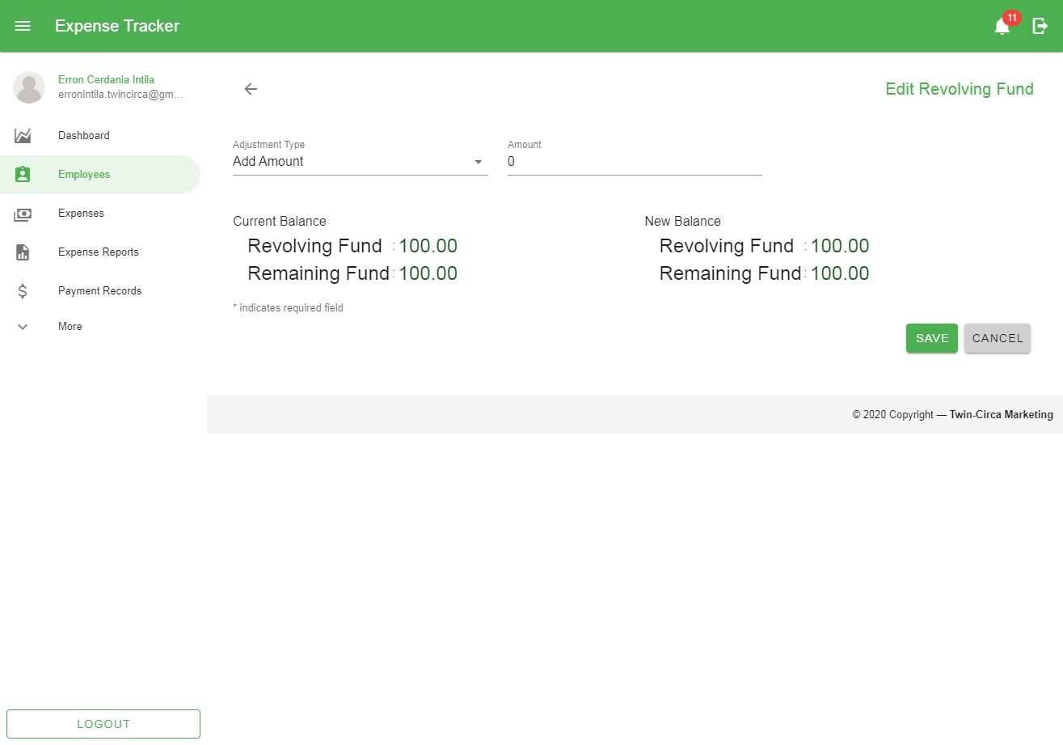

Figure 62 Edit revolving Fund Page

These are the following fields in the form:

1. Adjustment Type
2. Amount
3. Click the ‘Save’ button located at the bottom of the page.

### Editing Permissions

These are the steps in editing permissions:

1. Select the record by checking the checkbox in the first column of the data table.
2. Click the ‘Edit Permissions’ button shown above the Search bar along with other filter options to go to the Edit Permissions page.

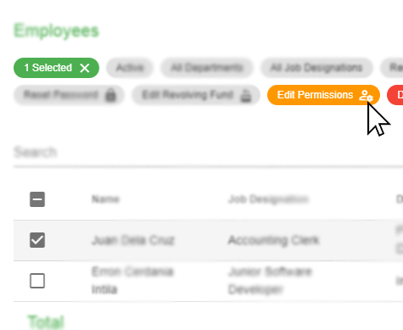

Figure 63 Edit Employee Permissions

1. Fill in the following details based on the image shown below.

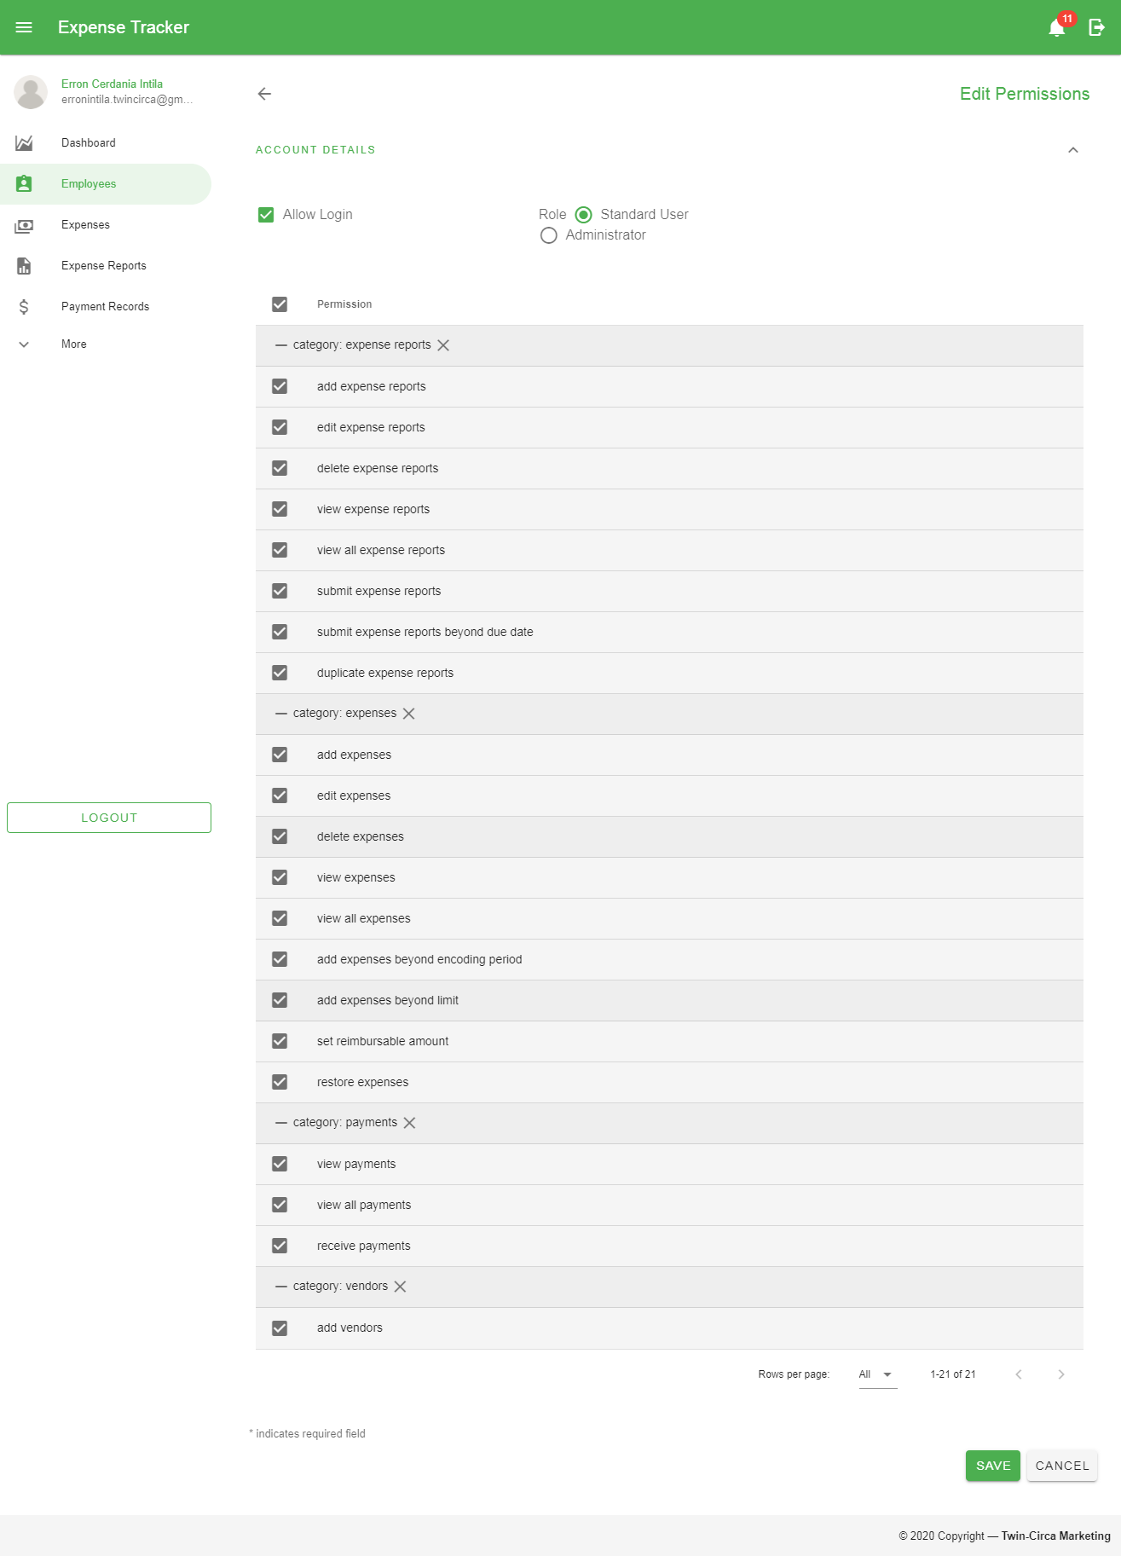

Figure 64 Edit Permissions Page

These are the following fields in the form:

1. Allow Login
2. Role
3. Permissions
4. Click the ‘Save’ button located at the bottom of the page.

### Deactivating and Activating Employees

#### Deactivating Employees

These are the steps in deactivating employees:

1. Select the record/s by checking the checkbox in the first column of the data table.
2. Click the ‘Deactivate’ button shown above the Search bar along with other filter options.

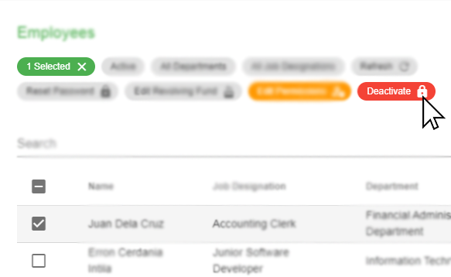

Figure 65 Deactivating Employee

1. Click the *‘Yes’* button in the popup dialog to confirm the action.

#### Activating Employees

These are the steps in activating employees:

1. Filter the records through the Status filter located at the top of the search bar and select ‘Inactive’.
2. Select the record/s by checking the checkbox in the first column of the data table.
3. Click the ‘Activate’ button shown above the Search bar along with other filter options.

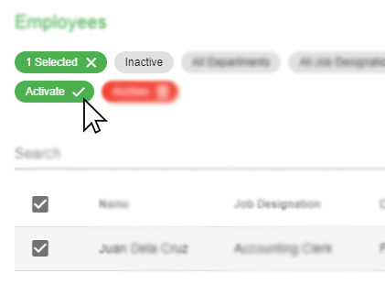

Figure 66 Activating Employee

1. Click the *‘Yes’* button in the popup dialog to confirm the action.

### Deleting Employees

These are the steps in deleting employees:

1. Filter the records through the Status filter located at the top of the search bar and select ‘Inactive’.
2. Select the record/s by checking the checkbox in the first column of the data table.
3. Click the ‘Archive’ button shown above the Search bar along with other filter options.

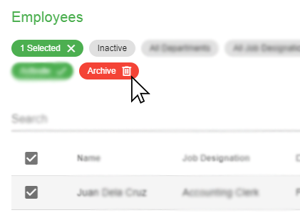

Figure 67 Deleting Employees

1. Click the *‘Yes’* button in the popup dialog to confirm the action.

### Restoring Employees

These are the steps in restoring employees:

1. Filter the records through the Status filter located at the top of the search bar and select ‘Archived’.
2. Select the record/s by checking the checkbox in the first column of the data table.
3. Click the ‘Restore’ button shown above the Search bar along with other filter options.

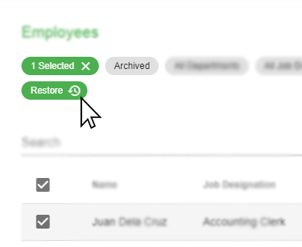

Figure 68 Restoring Employees

1. Click the *‘Yes’* button in the popup dialog to confirm the action.

## Vendor

This module provides management of vendor records. This includes creating, updating, and setting activation for each record.

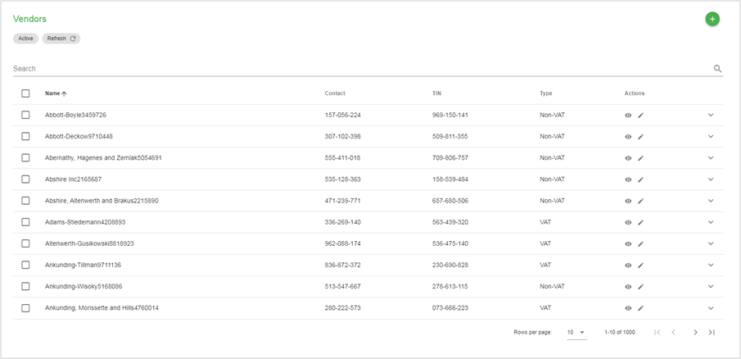

Figure 69 Vendor Page

### Creating New Vendor

These are the following steps in creating a new vendor:

1. Go to the Vendor page by navigating through the navigation drawer and click the Vendors menu.
2. In the Vendor page, click the Add button located at the top-right corner of the page content.
3. Fill in the following details based on the image shown below.

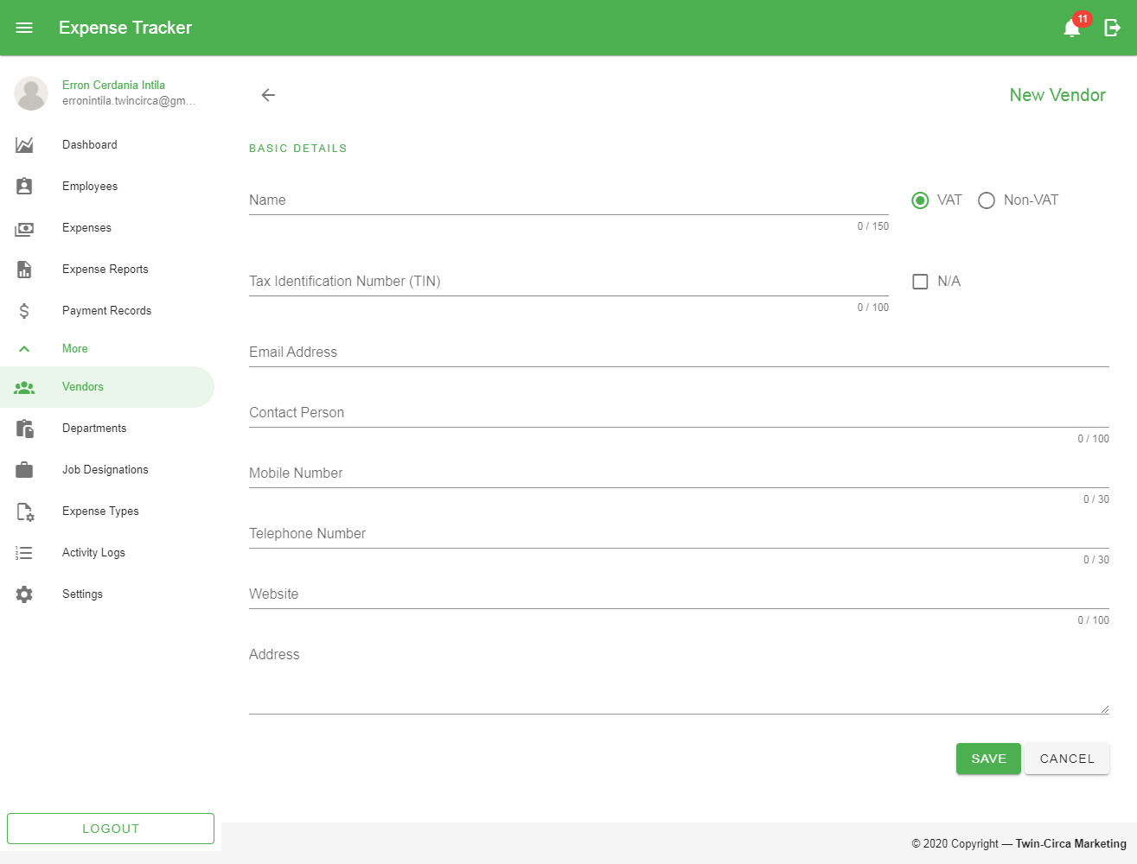

Figure 70 Vendor Add Form

These are the following fields in the form:

1. Name –
2. Tax Identification Number –
3. Email Address –
4. Contact Person –
5. Mobile Number –
6. Telephone Number –
7. Website –
8. Address –
9. Click the ‘Save’ button located at the bottom of the page.

### Editing Vendor

These are the following steps in editing a vendor:

1. In the Vendor Page, click the Edit button  in a particular row in the data table located within the Action column to go to the Edit Page.
2. Fill in the details to be updated.
3. Click the Save button located at the bottom of the page.

### Viewing Vendor

To view a specific record, click the Show button  in a particular row in the data table located within the Action column to go to the View Payment page for a more detailed information.

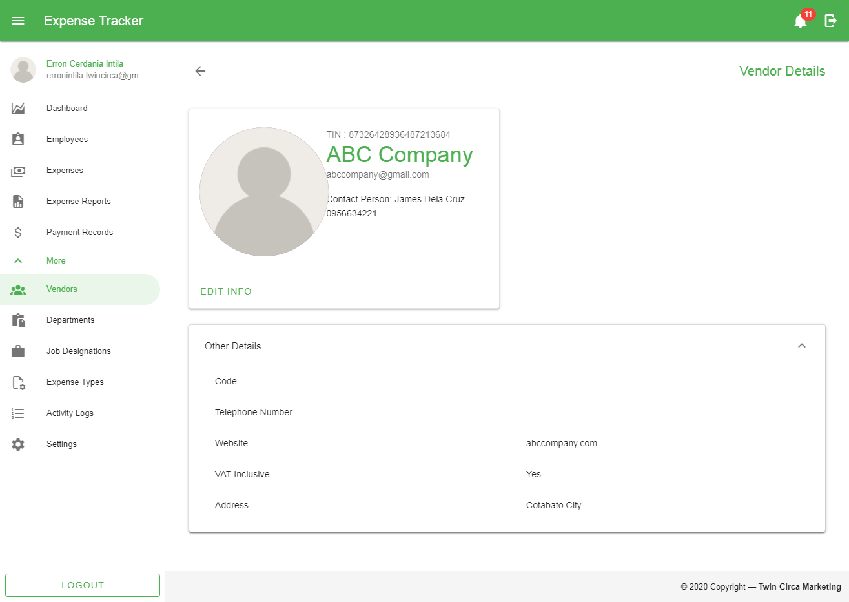

Figure 71 View Vendor Page

### Deactivating and Activating Vendors

#### Deactivating Vendors

1. Select the record/s by checking the checkbox in the first column of the data table.
2. Click the ‘Deactivate’ button shown above the Search bar along with other filter options.

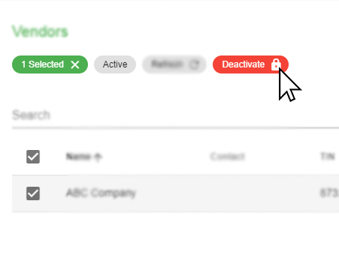

Figure 72 Deactivating Vendors

1. Click the *‘Yes’* button in the popup dialog to confirm the action.

#### Activating Vendors

1. Filter the records through the Status filter located at the top of the search bar and select ‘Inactive’.
2. Select the record/s by checking the checkbox in the first column of the data table.
3. Click the ‘Activate’ button shown above the Search bar along with other filter options.

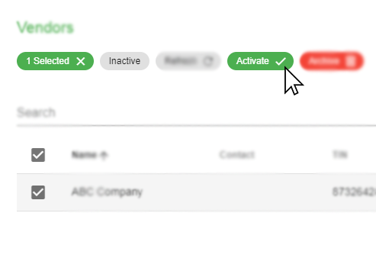

Figure 73 Activating Vendors

1. Click the *‘Yes’* button in the popup dialog to confirm the action.

### Deleting Vendors

Vendors can be deleted after the record/s have been deactivated. The following steps are as follows:

1. Filter the records through the Status filter located at the top of the search bar and select ‘Inactive’.
2. Select the record/s by checking the checkbox in the first column of the data table.
3. Click the ‘Archive’ button shown above the Search bar along with other filter options.

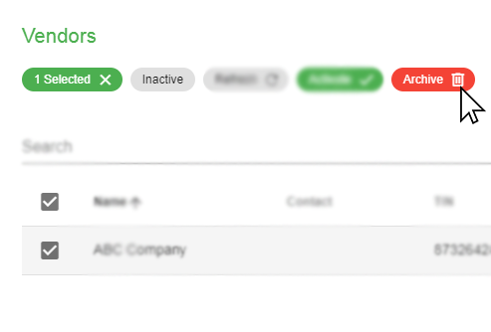

Figure 74 Deleting Vendors

1. Click the *‘Yes’* button in the popup dialog to confirm the action.

*Note: Aside from deactivating vendors, records can only be deleted if they have no active records (i.e. Expense records).*

### Restoring Vendors

These are the steps in restoring vendors:

1. Filter the records through the Status filter located at the top of the search bar and select ‘Archived’.
2. Select the record/s by checking the checkbox in the first column of the data table.
3. Click the ‘Restore’ button shown above the Search bar along with other filter options.

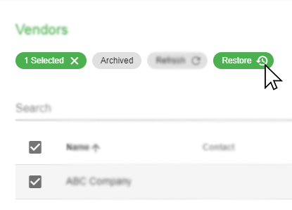

Figure 75 Restoring vendors

1. Click the *‘Yes’* button in the popup dialog to confirm the action.

## Department

This module allows the user to create, edit, and delete department records used to classify each employee/system user.

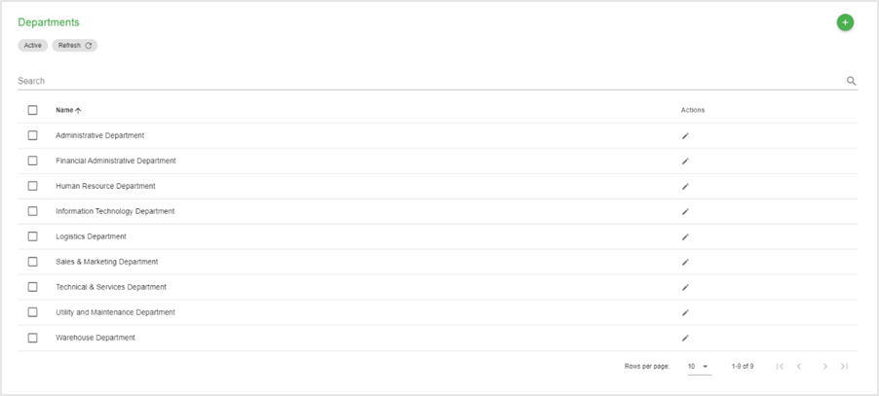

Figure 76 Department Page

### Creating New Department

These are the following steps in creating a new department:

1. Go to the Department page by navigating through the navigation drawer and click the Departments menu.
2. In the Department page, click the Add button located at the top-right corner of the page content.
3. Fill in the following details based on the image shown below.

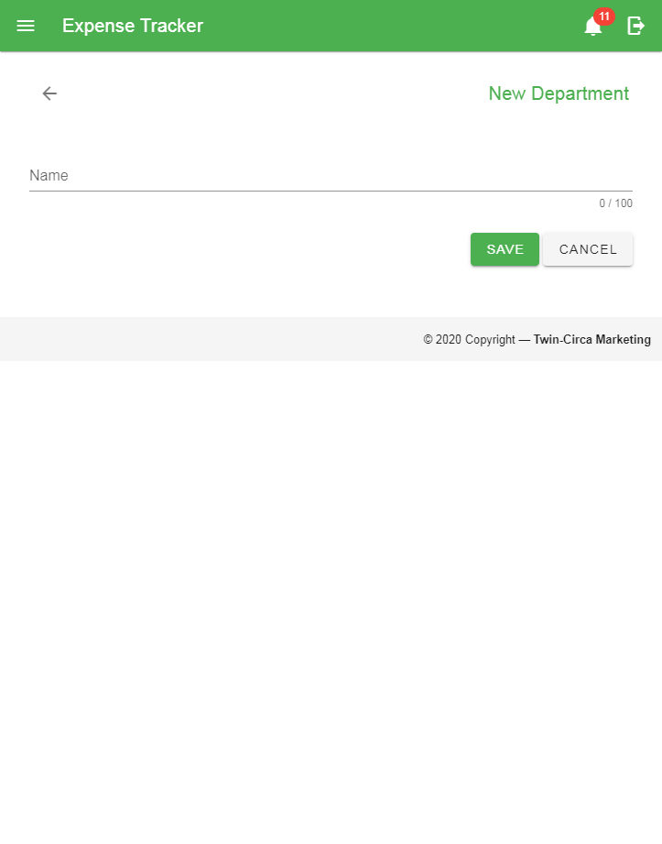

Figure 77 Department Add Form

These are the following fields in the form:

1. Name
2. Click the ‘Save’ button located at the bottom of the page.

### Editing Department

These are the following steps in editing a department:

1. In the Department Page, click the Edit button  in a particular row in the data table located within the Action column to go to the Edit Page.
2. Fill in the details to be updated.
3. Click the Save button located at the bottom of the page.

### Deleting Departments

These are the following steps in deleting a record:

1. Select the record/s by checking the checkbox in the first column of the data table.
2. Click the ‘Archive’ button shown above the Search bar along with other filter options.

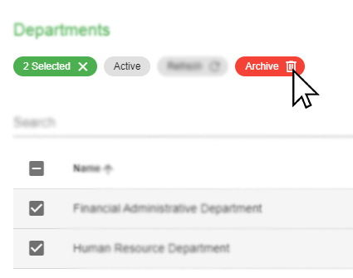

Figure 78 Deleting Departments

1. Click the *‘Yes’* button in the popup dialog to confirm the action.

*Note: Records can only be deleted if they have no active child records (i.e. Job Designation records).*

### Restoring Departments

These are the following steps in restoring a record:

1. Filter the records through the Status filter located at the top of the search bar and select ‘Archived’.
2. Select the record/s by checking the checkbox in the first column of the data table.
3. Click the ‘Archive’ button shown above the Search bar along with other filter options.

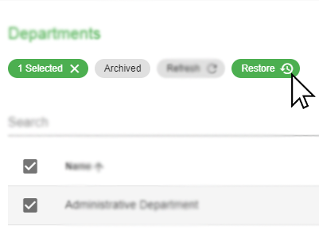

Figure 79 Restoring Departments

1. Click the *‘Yes’* button in the popup dialog to confirm the action.

## Job Designation

This module provides information about job designation records that can be used upon creating of new employees. This module also allows the user to create, edit, and delete job designation records.

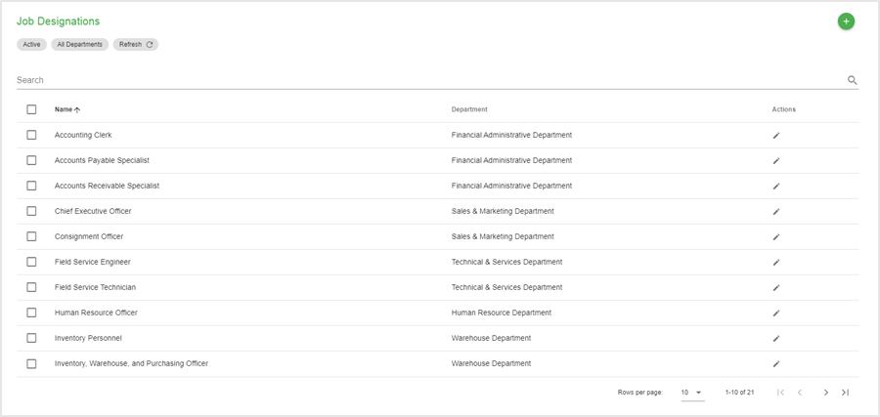

Figure 80 Job Designation Page

### Creating New Job Designation

These are the following steps in creating a new job designation:

1. Go to the Job Designation page by navigating through the navigation drawer and click the Job Designations menu.
2. In the Job Designation page, click the Add button located at the top-right corner of the page content.
3. Fill in the following details based on the image shown below.

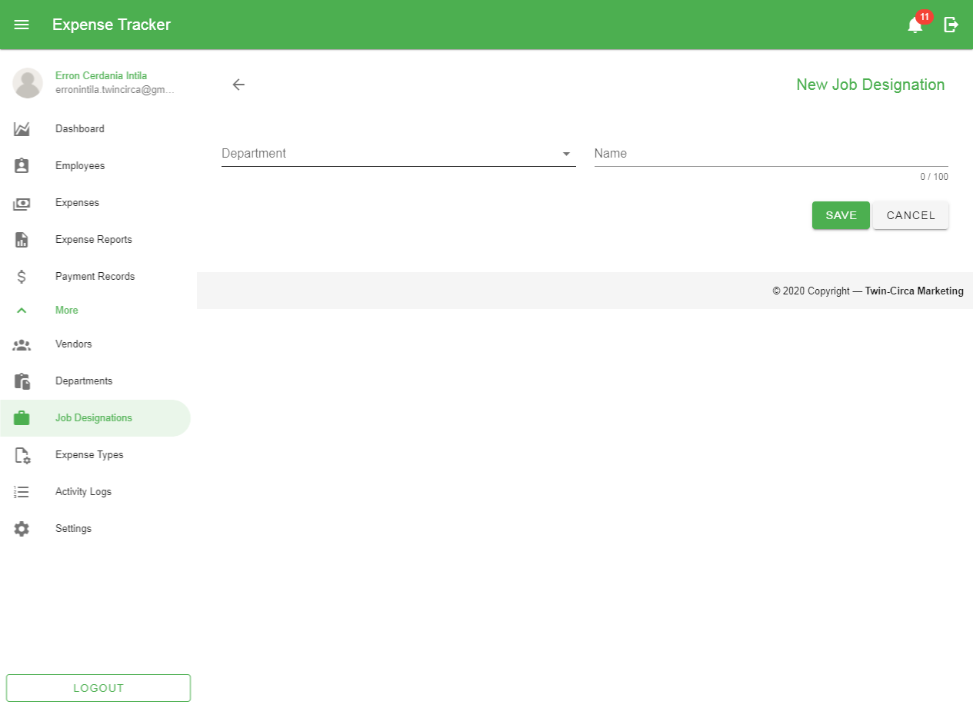

Figure 81 Job Designation Add Form

These are the following fields in the form:

1. Department
2. Name
3. Click the ‘Save’ button located at the bottom of the page.

### Editing Job Designation

These are the following steps in editing a job designation:

1. In the Job Designation Page, click the Edit button  in a particular row in the data table located within the Action column to go to the Edit Page.
2. Fill in the details to be updated.
3. Click the Save button located at the bottom of the page.

### Deleting Job Designations

These are the following steps in deleting a record:

1. Select the record/s by checking the checkbox in the first column of the data table.
2. Click the ‘Archive’ button shown above the Search bar along with other filter options.

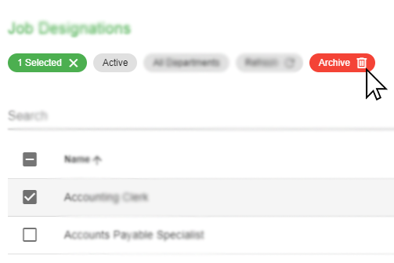

Figure 82 Deleting Job Designations

1. Click the *‘Yes’* button in the popup dialog to confirm the action.

*Note: Records can only be deleted if they have no active child records (i.e. Employee records).*

### Restoring Job Designations

These are the following steps in restoring a record:

1. Filter the records through the Status filter located at the top of the search bar and select ‘Archived’.
2. Select the record/s by checking the checkbox in the first column of the data table.
3. Click the ‘Archive’ button shown above the Search bar along with other filter options.

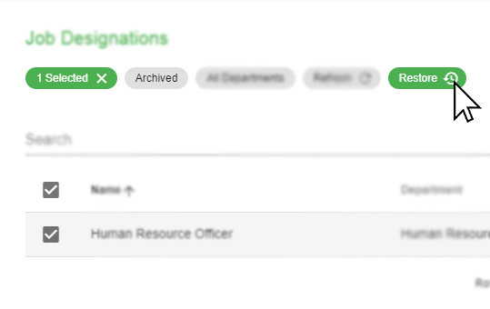

Figure 83 Restoring Job Designations

1. Click the *‘Yes’* button in the popup dialog to confirm the action.

## Expense Type

This module allows the user to create, edit, and delete expense type records used mainly on creating of expenses to provide classification when generating reports.

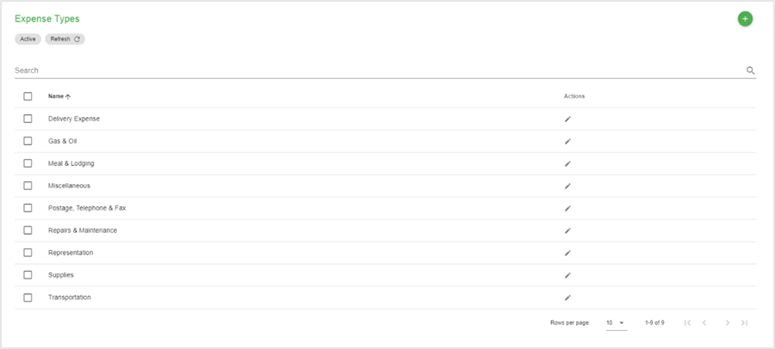

Figure 84 Expense Type Page

### Creating New Expense Type

These are the following steps in creating a new expense type:

1. Go to the Expense Type page by navigating through the navigation drawer and click the Expense Types menu.
2. In the Expense Type page, click the Add button located at the top-right corner of the page content.
3. Fill in the following details based on the image shown below.

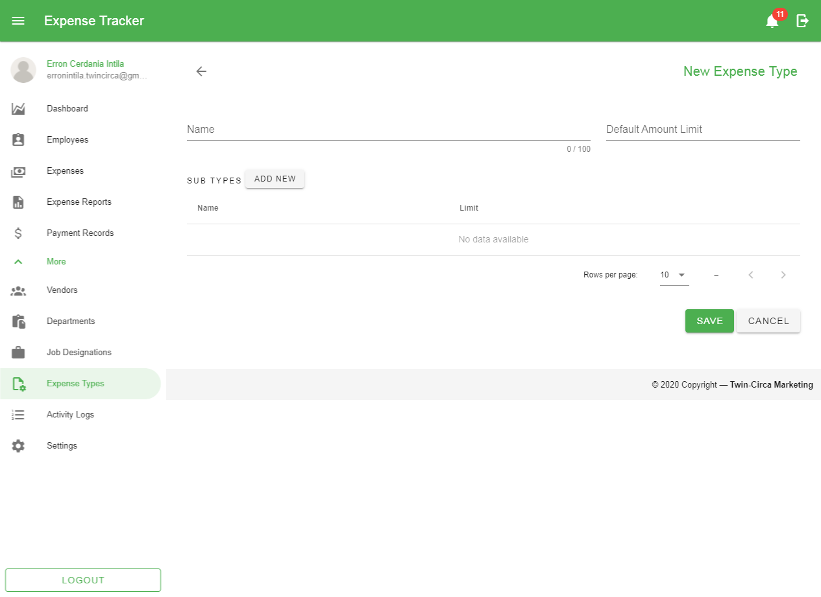

Figure 85 Expense Type Add Form

These are the following fields in the form:

1. Name –
2. Limit –
3. Sub Types –

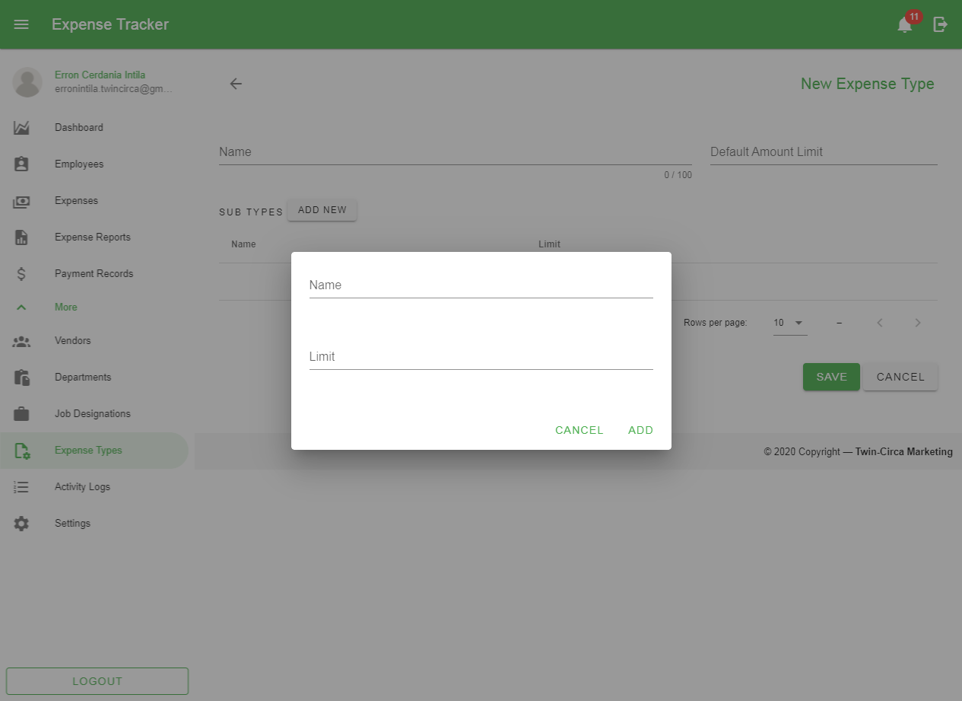

Figure 86 Add Subtype Form

1. Click the ‘Save’ button located at the bottom of the page.

### Editing Expense Type

These are the following steps in editing a department:

1. In the Department Page, click the Edit button  in a particular row in the data table located within the Action column to go to the Edit Page.
2. Fill in the details to be updated.
3. Click the Save button located at the bottom of the page.

### Deleting Expense Types

These are the following steps in deleting a record:

1. Select the record/s by checking the checkbox in the first column of the data table.
2. Click the ‘Archive’ button shown above the Search bar along with other filter options.

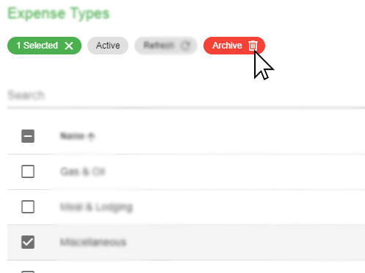

Figure 87 Deleting Expense Types

1. Click the *‘Yes’* button in the popup dialog to confirm the action.

*Note: Records can only be deleted if they have no active child records (i.e. Expense records).*

### Restoring Expense Types

These are the following steps in restoring a record:

1. Filter the records through the Status filter located at the top of the search bar and select ‘Archived’.
2. Select the record/s by checking the checkbox in the first column of the data table.
3. Click the ‘Archive’ button shown above the Search bar along with other filter options.

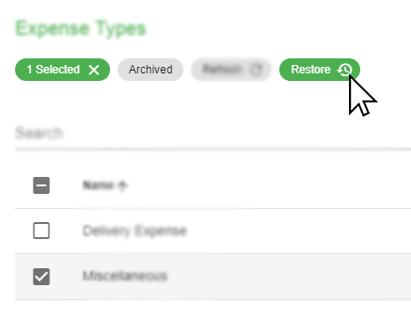

Figure 88 Restoring Expense Types

1. Click the *‘Yes’* button in the popup dialog to confirm the action.

## Activity Logs

This module displays user activities within the application.

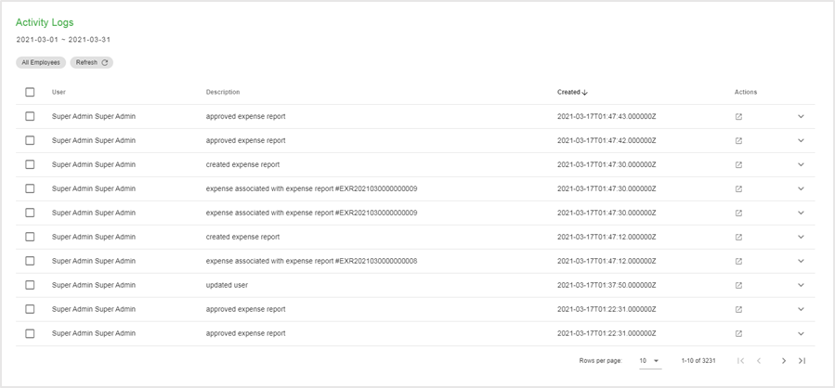

Figure 89 Activity Logs Page

## Notifications

This module provides a message that appears on the right side of the application. This is a way to let the user know that something new has happened within the application (e.g. submitting expense report) to avoid missing transactions that might be worth the attention of the user and appears whether the user is using the application or not.

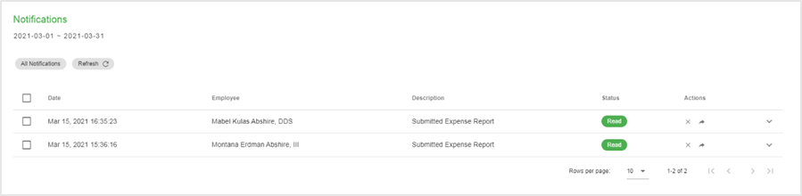

Figure 90 Notifications Page

### Viewing Notifications

These are the steps when viewing notifications:

1. Go to the Notification page by navigating through the application bar and click the Notification icon to open the Notification drawer.



1. In the Notification Drawer, click View All to go to the Notification page.

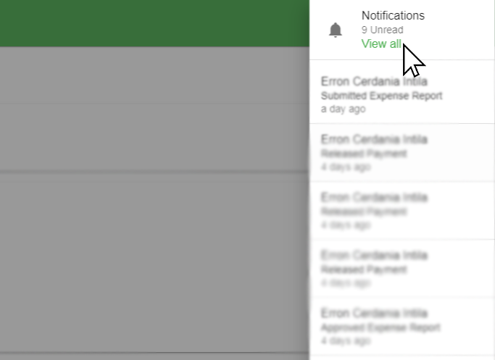

### Changing Notification Status

#### Mark All as Read

These are the steps when marking all the notifications as read:

1. In the Notification page, click the Mark All as Read button shown above the data table.

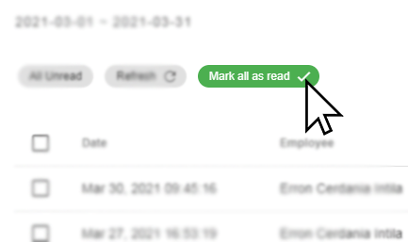

#### Mark as Read

These are the steps when marking notifications as read:

#### Mark as Unread

These are the steps when marking notifications as read:

## Settings

This module provides access to the user to set up and maintain the application. This involves configuration on different modules when creating and updating records.

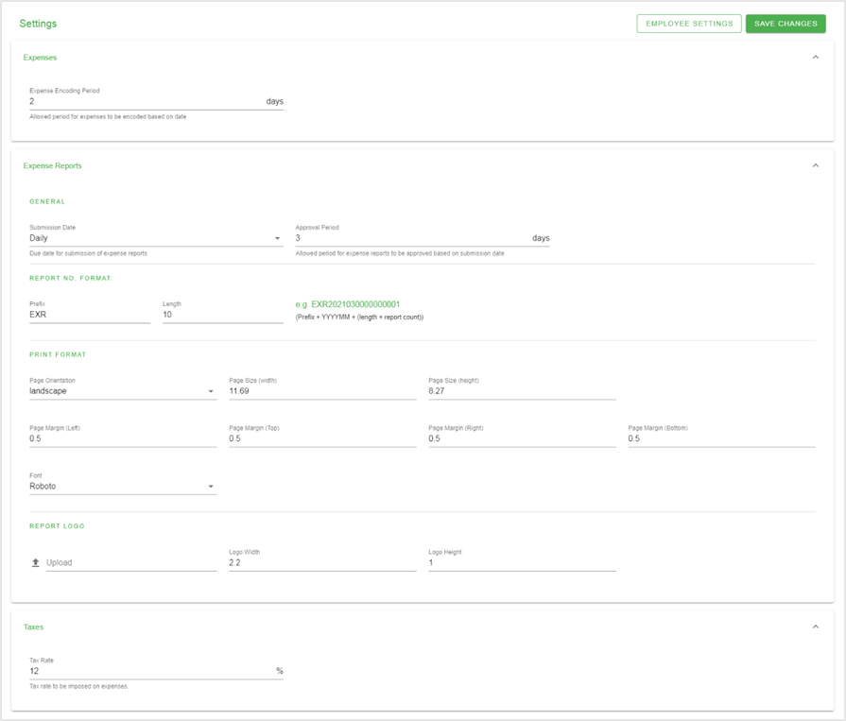

Figure 91 Settings Page

The settings are divided into following sections:

1. Expense Settings

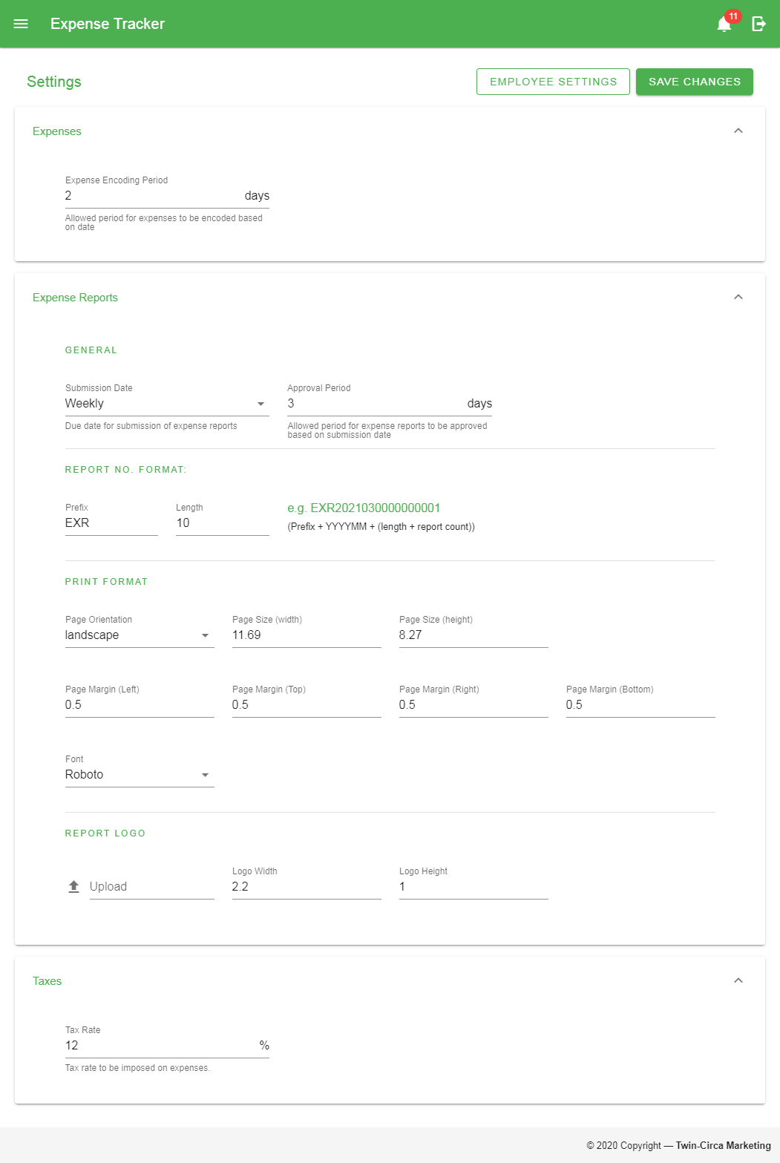

* 1. General
     1. Expense encoding period

1. Expense Report Settings

The Expense Report Settings are divided into different sections:

* 1. General



* + 1. Submission date
    2. Approval period
  1. Report No. format



* + 1. Prefix
    2. Length
  1. Print format



* + 1. Page Orientation
    2. Page Sizes (height and width)
    3. Page Margins
    4. Font
  1. Report Logo



* + 1. Image
    2. Logo Sizes (height and width)

1. Tax Settings



* 1. General
     1. Tax rate

### Employee Settings

This section provides a way for the user to assign different settings specific for each employee.

#### Expense Types

##### Allowed Expense Types

This setting assigns an employee with the allowed expense types that can be applied when creating expenses.

These are steps in selecting allowed expense types for the employee:

1. Click the ‘Select Employee’ button to open a dialog on selecting employees.

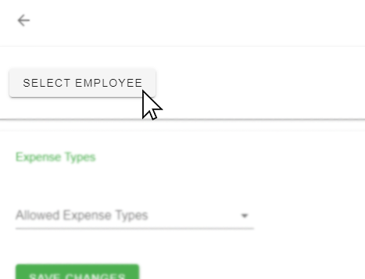

1. After selecting employee, click the Expense Type Dropdown button.

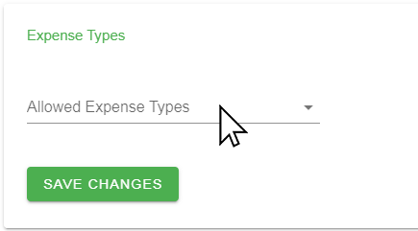

1. Select the expense types through the checkboxes from the list.

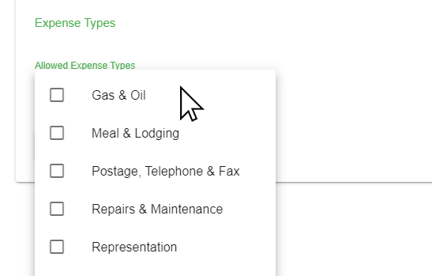

1. Click the *‘Save Change’* button to apply the update.

# Appendices

## Definition of Terms

## Figures

Figure 1 Application Bar 3

Figure 2 Page content 4

Figure 3 Navigation Drawer 5

Figure 4 Application footer 5

Figure 5 Search bar 6

Figure 6 Status filter 6

Figure 7 Sorting data table 6

Figure 8 Refresh button 7

Figure 9 Showing additional row data 7

Figure 10 Selecting data table row data 7

Figure 11 Perform actions on a row data 8

Figure 12 Pagination 8

Figure 13 Search Bar 9

Figure 14 Date Range Picker Button 9

Figure 15 Date Range Picker 10

Figure 16 Status Filter 10

Figure 17 Expense Status Filter 11

Figure 18 Expense Report Status Filter 11

Figure 19 Payment Status Filter 11

Figure 20 Notification Status Filter 12

Figure 21 Employee Selector Button 12

Figure 22 Employee Selector 12

Figure 23 Department Selector 13

Figure 24 Job Designation Selector 13

Figure 25 Login page 14

Figure 26 Dashboard 18

Figure 27 Expense Summary Dashboard Section 19

Figure 28 Expense Reports Summary Dashboard Section 19

Figure 29 Expense By Category Dashboard Section 19

Figure 30 Expense By date Dashboard Section 20

Figure 31 Dashboard Date filter 20

Figure 32 User Profile 21

Figure 33 Change Password Button 21

Figure 34 Change Password Form 22

Figure 35 Expense Page 23

Figure 36 Create Expense Form 24

Figure 37 Itemized Expenses Table 25

Figure 38 Add Expense Form for Itemized Expenses Record 25

Figure 39 View Expense Page 26

Figure 40 Cancelling Expenses 27

Figure 41 Restoring Expenses 27

Figure 42 Expense Report page 29

Figure 43 Expense Report Add Form 30

Figure 44 Selecting expenses for Expense Report 30

Figure 45 View Expense Report Page 32

Figure 46 Submitting Expense Reports 32

Figure 47 Printing/Exporting Expense Reports 33

Figure 48 Approving/Rejecting Expense Reports 34

Figure 49 Cancelling Expense Reports 34

Figure 50 Duplicating Expense Reports 35

Figure 51 Payment Add Form 37

Figure 52 Selecting Expense Reports for Payment Record 38

Figure 53 View Payment Page 38

Figure 54 Marking Payment as Received 39

Figure 55 Cancelling Payment Record/s 39

Figure 56 Employee Page 40

Figure 57 Employee Add Form (Basic Details) 41

Figure 58 Employee Add Form (Account Details) 42

Figure 59 View Employee Page 44

Figure 60 Employee Reset Password 45

Figure 61 Edit Employee Revolving Fund 45

Figure 62 Edit revolving Fund Page 46

Figure 63 Edit Employee Permissions 46

Figure 64 Edit Permissions Page 47

Figure 65 Deactivating Employee 48

Figure 66 Activating Employee 48

Figure 67 Deleting Employees 49

Figure 68 Restoring Employees 49

Figure 69 Vendor Add Form 51

Figure 70 View Vendor Page 52

Figure 71 Deactivating Vendors 53

Figure 72 Activating Vendors 53

Figure 73 Deleting Vendors 54

Figure 74 Restoring vendors 54

Figure 75 Department Page 55

Figure 76 Department Add Form 56

Figure 77 Deleting Departments 57

Figure 78 Restoring Departments 57

Figure 79 Job Designation Page 58

Figure 80 Job Designation Add Form 58

Figure 81 Deleting Job Designations 59

Figure 82 Restoring Job Designations 60

Figure 83 Expense Type Page 61

Figure 84 Expense Type Add Form 62

Figure 85 Add Subtype Form 62

Figure 86 Deleting Expense Types 63

Figure 87 Restoring Expense Types 63

## Troubleshooting

### Software Troubleshooting

### Network Troubleshooting

### Important Notes